**Language Contact and Human Prehistory**

**Contents**

**Abstract**

**Chapter 1: Introduction**

**Chapter 2: The Family Tree of Sound Systems**

**Chapter 3: Linguistic Areas and the Prehistoric Migrations**

**Chapter 4: Language Contact in Austroasiatic Languages of Southwest China**

**Chapter 5: A Brief History of Tone**

**Chapter 6: Conclusion**

**Bibliography**

**Chapter 1: Introduction**

One of the greatest achievements of linguistics has been the discovery of language families. Over five hundred languages stretching from western Europe to Nepal have been demonstrated to have descended from a common ancestor. Another example is the Austronesian languages of the Pacific and the Indian Ocean, from Madagascar to Hawaii, which have been shown to be the descendants of a single language once spoken in Taiwan. We know that these languages form families because of striking similarities in their core vocabulary, such as shared words for ‘father’ across languages of Europe and India (German: Vater, Latin *pater*, Spanish: padre, Ancient Greek πατήρ, Tocharian pacer, Persian *pedar*, Vedic Sanskrit: *pitā́*) , which show that they are descended from a single language.

Many of the world’s 7-8000 languages can be shown to belong to just 273 families, whose distributions are shown in the map below. Each polygon shows the boundary of a family. Besides these 273 families, there are approximately 188 language isolates.

Figure 1: distribution of language families in Glottolog (Hammarström et al. 2014). This suggests that these languages began as dialects of a single language, and have been slowly diverging since then.

The existence of language families such as Indo-European raises historical questions. Why did the descendants of a single language, Proto-Indo-European, come to be used over such a large area? Where and when was Proto-Indo-European spoken? Did these languages spread with people, such that these migrations are also detectable by genetics? Is there any archaeological record of what may have given these speakers some advantage, such as a particular kind of agriculture, weaponry or mode of transport? A further holy grail of linguistics has been to find the closest relatives of Indo-European, and more generally to unite language families into larger units and push our knowledge of language history even further back in time.

This thesis is about the history of languages, but from a different perspective: the history of language contact. Languages interact with each other to different extents, from borrowing words to more intensive cultural influence, where languages can be restructured in fundamental ways, such as in their grammatical systems and in the sounds that they use (Thomason and Kaufman 1998:50). An example of the latter is English as spoken in Singapore, which has grammatical features more akin to Chinese or Malay than they are to English such as deleting the copula (‘My handwriting not clear’), using sentence final particles (‘Hurry up la’), and using pitch in a level tone on words, perhaps an incipient form of lexical tone (Goh 1998).

This restructuring of English under the influence of Chinese in particular (which has the three features described above) can help explain why languages in some parts of the world share similar properties, despite not necessarily being related. Many languages in Southeast Asia for instance have a distinctive profile of sounds. In an online game called ‘The Great Language Game’, in which players listen to an audio recording and try to guess what language is being spoken, languages such as Thai, Vietnamese and Mandarin Chinese are among those that are frequently confused with each other by non-native speakers. This lends support to the notion that they sound similar, despite actually being from different language families (Tai-Kadai, Austroasiatic and Sino-Tibetan respectively).

Areas like this may be described as ‘linguistic areas’, a term which has been used to describe groups of languages which seem to be similar at least partly because they have been interacting with each other because bilingual speakers have been migrating between these groups (Trubetzkoy 1928, Thomason and Kaufman 1988:95-97). Southeast Asia is a particularly striking example, as is shown by Enfield (2005) which lists phonological properties such as tone, large vowel inventories, and constrained syllable codas, as well as syntactic properties such as Subject-Verb-Object word order, numeral classifiers, and lack of inflectional morphology. Linguistic areas in various parts of the world have been described, such as in the Balkans (Joseph 1983), Meso-America (Campbell 1986), Northern California (Sherzer 1973), India (Emeneau 1956), Australia (Dixon 2001), Africa (Heine and Nurse 2008) and South America (Aikhenvald 2002, Crevels and van der Voort 2008).

Compared with language families however, linguistic areas are far less well substantiated, and their history often poorly understood. This thesis is about linguistic areas in Eurasia, focusing on Southeast Asia in particular. It addresses the question first of whether linguistic areas can be supported statistically, such as that we can say with confidence that the Southeast Asian linguistic area exists. If it does exist, it raises questions such as how it originated; what the chronology was of languages becoming similar to each other; whether it was created by a large scale migration of people, or by a slow process of cultural influence between neighbouring languages; and whether there may be archaeological and genetic correlates of linguistic areas, as there may be with language families.

1. **Macro-Areas**

Most remarkable is when languages over a very large geographical area have properties in common. For example, languages across Siberia, India and as far east as Japan share similar word orders, and various other features described in databases such as the World Atlas of Language Structures (Dryer and Haspelmath 2013). Some linguists have seen this as evidence for relatedness of some of these languages in a large family, such as Trans-Eurasian (e.g. Robbeets). But because languages interact with each other, one does not have to postulate a language family to explain these similarities, if languages across Siberia have converged on recognisably similar structural properties.

Like macro-language-families, these macro-areas are controversial, and would raise large historical questions. One aim of this thesis is to demonstrate that these areas exist. There are however several challenges to demonstrating that even smaller, apparently well-established linguistic areas exist, despite the large literature describing them. Most work on linguistic areas simply makes their case by listing idiosyncratic features that are shared by only languages in that area, an approach that Muysken et al. (2014) describes as as ‘bottom-up’. Quantifying how similar languages are is the first challenge, including deciding which properties to compare, and how to measure them objectively. There then needs to be a statistical procedure for determining what which languages are most similar to each other, controlling for the possibility that some similarity is due to chance.

Some papers statistically test differences between geographical regions, which Muysken et al. (2014) calls a ‘top-down’ approach. An example is Birchall (2014), which tests for whether particular features are more common inside a pre-defined geographical area than outside of it. This is also the approach taken by a controversial study on a putative macro-area, the Pacific Rim, in Bickel and Nichols (2006).

The problem with this approach is that it does not take into account the non-independence of languages within the proposed area. Languages are related, first of all. Second, languages may be in contact with each other on a more local scale. For instance, a language in Southeast Asia may borrow some properties from another language, without this meaning that we should treat the entire region as a linguistic area. The effects of contact need to span many languages, and should be detectable even when we control for more banal forms of local borrowing.

This problem is particularly acute for Bickel and Nichols (2006)’s claim that there is a large linguistic area around the Pacific Rim. Their claim is based on the fact that many linguistic variables are more common within this area than outside of it, such as numeral classifiers, possessive classes, and so on. However, their sample includes many related languages, as they sample one language per ‘genus’ (an arbitrary unit of relatedness from the World Atlas of Language Structures), and hence this could simply reflect the higher frequency of these variables in certain families. Even discounting that possibility, it may simply demonstrate that there are linguistic areas which are rather smaller than their proposed Circum-Pacific area; for instance, the Meso-American area, or a Californian area.

This problem is also present in more conservative studies of linguistic areas. Birchall (2014)’s attempt to quantify differences between areas again does not take into account that there may simply be more local instances of contact (or relatedness) causing the higher frequency of these variables in certain regions, without this meaning that there is a linguistic area covering the entirety of the proposed region. The problem is present more implicitly in non-quantitative work, whenever a linguist attempts to delineate where an area ends.

A different way of stating this problem is that linguistic areas have a hierarchical structure. There can be linguistic areas within linguistic areas, just as there are sub-families within language families (Germanic within Indo-European, for example). Languages in India may form a linguistic area, for instance, while also being part of a larger Eurasian area. And within India, related languages will be more structurally similar to each other than non-related languages on average, and neighbouring languages will be more similar than non-neighbouring languages.

A key part of the definition of a linguistic area is that there has been diffusion across unrelated languages. But nobody would deny that there is normal inheritance also happening in a linguistic area. The Southeast Asian area for instance has both processes, forming a large linguistic area at least in part because the families themselves are large. Another complication is that related languages can influence each other, creating indeterminate situations where it is unclear whether languages have inherited similar properties or influenced each other.

Daumé III (2009) presents a Bayesian method distinguishing between these processes by modelling linguistic features as both inherited genealogically and subject to areal influence by languages within a particular radius. The method identifies plausible linguistic areas such as the Balkans, parts of India, Meso-America and so on, as well as a ranking of features by how likely they are to be borrowed.

**2. Bayesian Phylogenetic Methods**

The approach taken in this thesis is different from this previous work in that it attempts to find clusterings of languages based on their structures, without using geographical information at all. Other challenges described above, such as the problem of multiple testing, how to delineate linguistic areas given that there are areas within areas, and how to quantify similarity of languages given that not all features are equally informative, will be dealt with by a particular method from phylogenetics, the branch of biology that studies evolutionary relationships among species.

In biology, species are related to each other in a family tree, reflecting the fact that they have diverged from common ancestors; humans are closely related to chimpanzees, more distantly to gorillas, more distantly still to orangutans, and so on. Languages also form family trees which are richly structured, such that we can be confident of the existence of a language that was the ancestor of the Germanic languages (Proto-Germanic), and further back in time, the ancestor of all Indo-European languages (Proto-Indo-European). For this reason, phylogenetic methods have been successfully applied to reconstructing family trees of languages, by treating vocabulary as analogous to biological traits.

Languages can be demonstrated to be related by using vocabulary data (typically short lists such as Swadesh lists) and making a model of how the sounds of words change over time. Traditional historical linguists do this implicitly when they make judgements about which words are cognates, and how plausible particular sound changes may have been, but it can also be made into a quantitative method, using software for inferring family trees of species in biology (BEAST 2, Bouckaert et al. 2014). Using these tools, linguists hope both to clarify the origins of known language families (e.g. Bouckaert et al. 2012 on Indo-European) and perhaps even to discover macro-families (Jäger 2015).

The approach taken since Gray and Jordan (2000) is to code for the presence or absence of cognate vocabulary. For example, main in French and mano in Italian are similar enough that they are likely to be related (or borrowed); hence one can code French and Italian as 1 (meaning they have a word which is part of this cognate class), and English as 0 because it has hand, which is not in this cognate class. English then gets a 1 for the next cognate class (cognates of hand, which exist in Germanic languages), while French and Italian get 0. This string of 0’s and 1’s can be read into phylogenetic software in the same way that a DNA sequence can be, and can be analysed using a Bayesian method to work out what family trees are particularly probable.

Bayesian phylogenetics asks what the likelihood of a family tree is, namely with what probability the data would be the way that it is if the hypothesis (the family tree being proposed) were true. This can be calculated by summing over all possible scenarios of how an individual trait may have evolved: main may have been in the ancestor of all Indo-European languages and then lost in the Germanic branch for instance, or it may have been absent in Proto-Indo-European but innovated by the Romance languages; or it may have been present in Proto-Germanic as well but then lost by all of the modern Germanic languages; and so on. The probability of all of these possible scenarios can be calculated by using a model of trait evolution which has the probability of a trait being innovated, in this case how likely a language is to have main or a cognate of it as a word for ‘hand’; and the probability of the language losing that trait, in this case a language having main as the word for ‘hand’ but then innovating a different word for ‘hand’ and using that instead. Some words will be slow-changing, such as the word for ‘two’ which has been conserved in all branches of Indo-European (recall the modern words for ‘two’ such as French deux, Greek duo, Russian dva, and Hindi do), while most words change more quickly.

The probability of a particular scenario of how a word evolved can be calculated by using these probabilities, and the proposed family tree. The family tree not only specifies how languages are related (such as English being the closest cousin of Dutch), but also how much time has elapsed since they diverged (perhaps 1000 years in the case of English and Dutch). The amount of time is taken into account when calculating the probability of words being lost or gained, as the more distantly that languages are related, the more probable it is that changes in vocabulary will occur.

Finally, all possible scenarios are summed (using Felsenstein’s tree pruning algorithm, Felsenstein ...) to produce the likelihood of the tree for that particular word. This is calculated for each word, and the product of all of these likelihoods is the overall likelihood of the tree. This number can then be multiplied by the prior probability of the tree (a number that reflects how probable a particular tree topology is, given that certain tree shapes may be quite unusual), and this gives the posterior probability of the tree. The details of this calculation are described in Huelsenbeck et al. (2001).

There are many possible ways that languages can be related in a tree, and it is impossible to calculate the probability of all of them. Instead, an algorithm is used that searches through trees and samples them according to their probability, the Markov Chain Monte Carlo (MCMC) algorithm (). The result of running a MCMC chain for typically many millions of iterations will be a set of trees, most of which will fit the data well. This set of trees will reflect the different possible solutions to the question of what the real tree is. It can be summarised by a single consensus tree, which shows groupings (clades) that occur most often in the set of trees found by the algorithm; for example, it may turn out that in 97% of trees in the sample, English is the closest relative of Dutch, and so a consensus tree would put them together and give that clade a 97% probability. Other clades will have much lower probabilities, especially those further back in time.

Phylogenetic methods have been instrumental both in demonstrating that families actually exist and have a well-defined structure, in a quantitative way; and also in clarifying their origins, including their ages and their homelands. There has even been a statistical move towards finding macro-language-families, by comparing vocabulary lists and quantifying similarity between them using a phylogenetic method (Jäger 2015).

The use of phylogenetic methods to study languages raises an immediate problem, namely that languages borrow from each other in ways that species in biology typically do not (with exceptions even there, such as inter-breeding between closely related species, or horizontal gene transfer in bacteria). The use of a model where vocabulary is transmitted in a single tree inevitably is a simplification, and potentially leads to large errors. This should be taken seriously and new models proposed to overcome this obstacle, and in this vein I propose a ‘mixture model’ at the end of Chapter 2. But it is also worth noting that this simplification is no worse than the implicit simplification made by other historical linguists; they have been looking for the structure of families such as Indo-European and Austronesian (defining sub-groups) and trying to exclude borrowing when doing so.

**2. Phylogenetics of Language Structures**

Rather than applying these methods to vocabulary data, they can also be applied to structural data. Dunn et al. (2005) pioneered this approach by collecting grammatical data on languages in Island Melanesia, and applied a phylogenetic method to show that languages also seem to form family trees based on their structures, in the absence of using vocabulary data. The aim of that paper was to argue that structural data can be used to infer genealogical relationships. Work since then has argued against this, most recently Greenhill et al. (2017) which shows that structural features evolve quickly in known language families such as Austronesian.

This thesis instead uses the phylogenetic method to study the way that languages have been influencing each other both by inheritance and by language contact. The approach is identical to the analysis of vocabulary in languages, but simply taking linguistic structures as the data rather than vocabulary. A language is summarised as a set of features, such as how many consonants it has, what word orders it has, whether it has tone, and so on.

One does not normally think of a family tree of structures, but it is no stranger than assuming that vocabulary forms a family tree. If instead one imagines the language as a set of structures, the transmission of the language can continue by substrate influence, such as Chinese into Hong Kong English. Hong Kong English in this view is a descendant of Chinese - although of course it will have some of the structures of English. The resulting family tree of languages according to their structures will overlap with the tree that is based on vocabulary (varieties of Chinese are structurally similar as well as related), but not entirely, because there is also horizontal transmission of structures.

Chapter 2 applies this method to a phonological data from languages in Eurasia, from the World Phonotactics Database (). This database has data on over 3000 languages, and is therefore more suitable than other structural databases such as the World Atlas of Language Structures () which is much more sparse. The result of a phylogenetic analysis is a family tree of languages, with particular clades representing likely linguistic areas. The database and the methods are described in more detail in Chapter 2, but some findings can be presented here.

Rather than there being a single Southeast Asian area for example, there are several different groupings of languages in that region. One of them does indeed resemble the Southeast Asian linguistic area, but it does not include all languages in the region, and it also includes Korean (Figure 1).

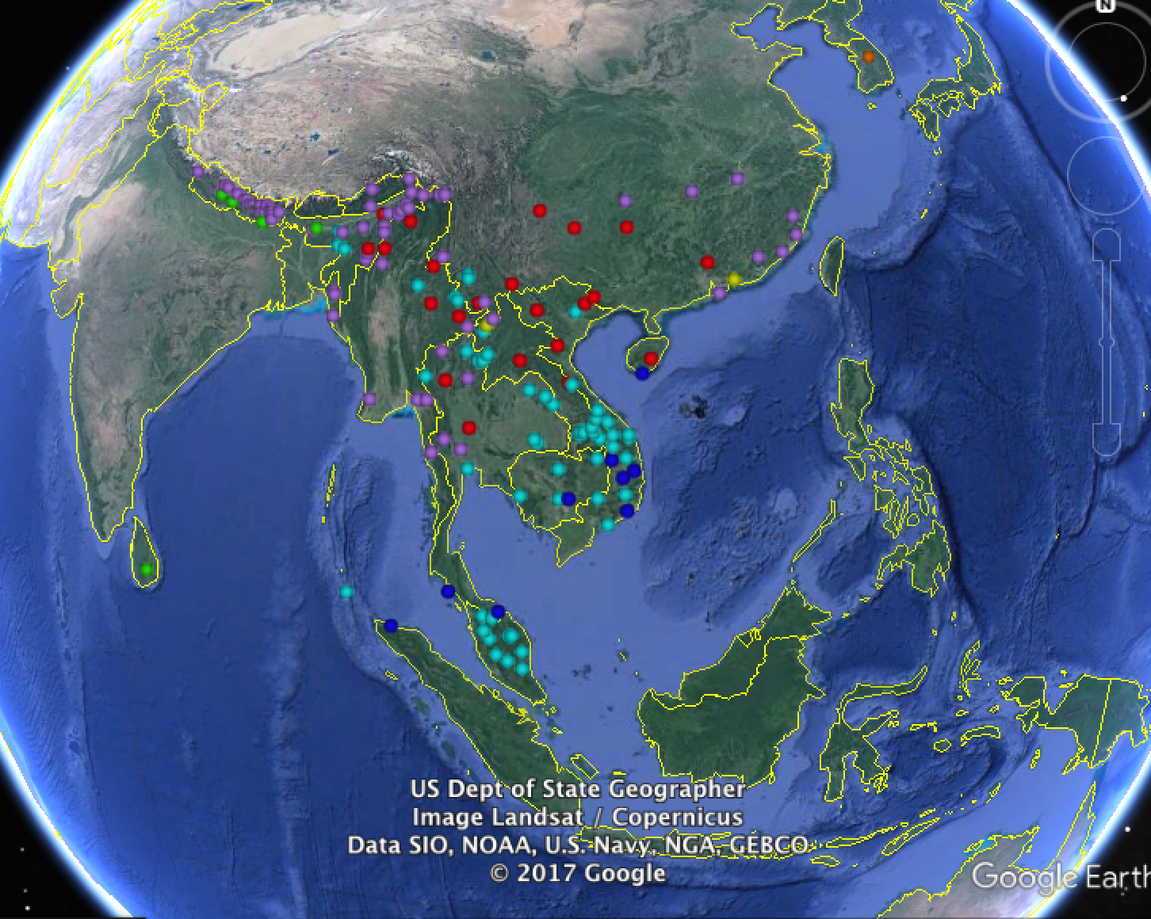

Another separate linguistic area is in south China, as shown in Figure 2. The languages are coloured to show their language family (Sino-Tibetan in dark blue, Hmong-Mien in red, Tai-Kadai in yellow and Austroasiatic in light blue).

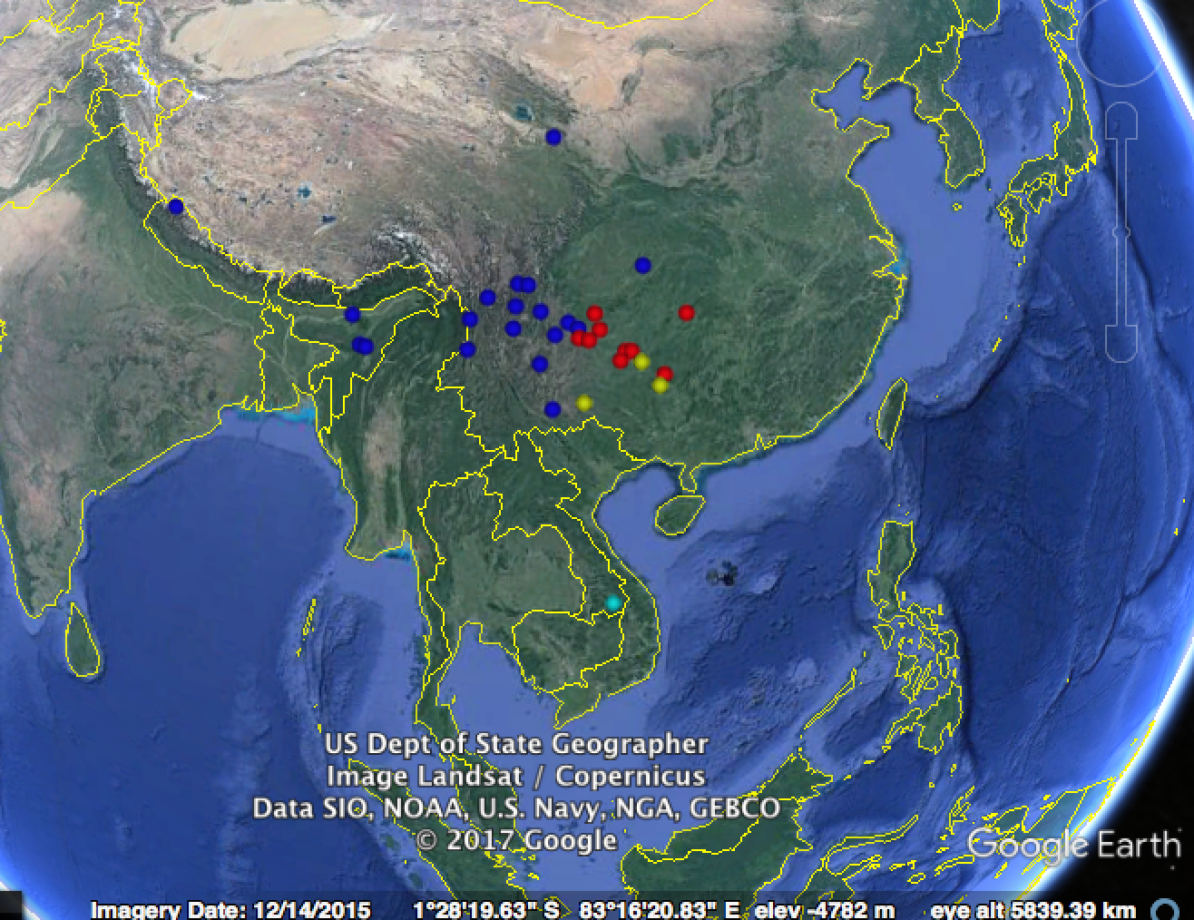

This area may be thought of as a south China area, mostly comprising Sino-Tibetan and Hmong-Mien languages, with a few Tai-Kadai languages and one Austroasiatic language (which may be a mistake since it is further away in southern Laos). This area has relatively strong support in this analysis (72%). In the consensus tree that emerges from the phylogenetic analysis, this clade is in fact on the outside of the tree, with all other languages in Eurasia forming a clade with 56% posterior probability. This means that other Eurasian languages have more in common with each other than they do with languages in the south China area. A more contentious way of putting it would be that there is evidence for all Eurasian languages outside of south China being a linguistic area, that is, sharing some properties in common. Perhaps this is just an artifact of the fact that only Eurasian languages are used in this analysis; if languages from other continents were included, it may turn out that this clade is no longer strongly supported, or that it is supported and is due to most languages in Eurasia having a common historical signal (either due to inheritance or, more likely, the influence of large families such as Indo-European). This large area is therefore hard to interpret, but is worth noting as a strength of the method - that it can in principle detect large areas that linguists would not even have thought of looking for (an entire continent minus an area could in principle be a linguistic area).

A different area which one might call the Indosphere also emerges, covering India, the Himalayas, and many languages in the west of Southeast Asia, particularly in the Austroasiatic family. This is not surprising given that two of the Southeast Asian language families, Austroasiatic and Sino-Tibetan have branches in India, and they have had extensive contact with Indo-European languages there.

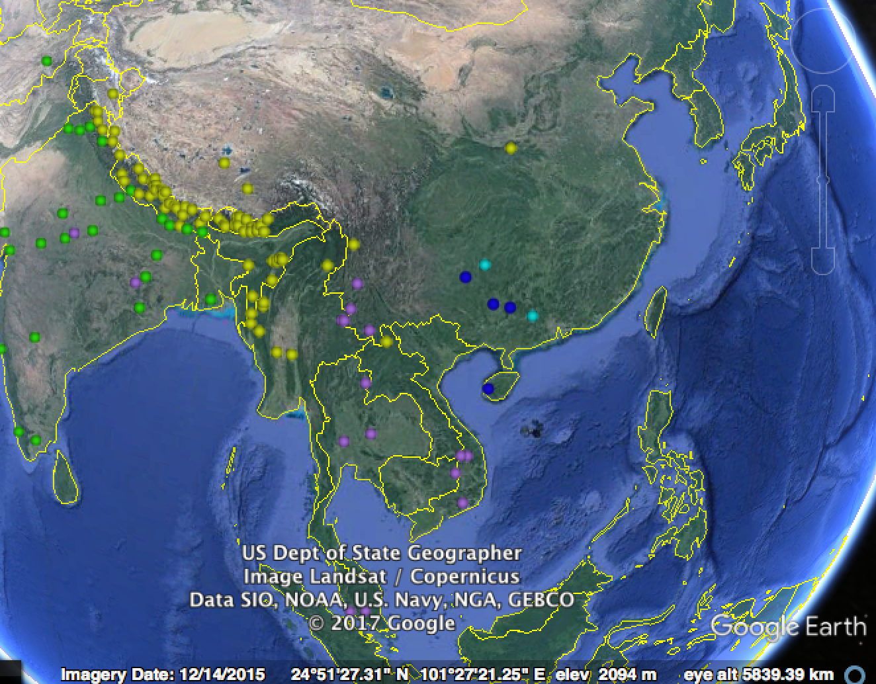

As already alluded to, linguistic areas can be made up of smaller linguistic areas. In this case the area in Figure 3 divides neatly into two smaller areas, one in Southeast Asia and one in India. The smaller area in India is shown in Figure 4.

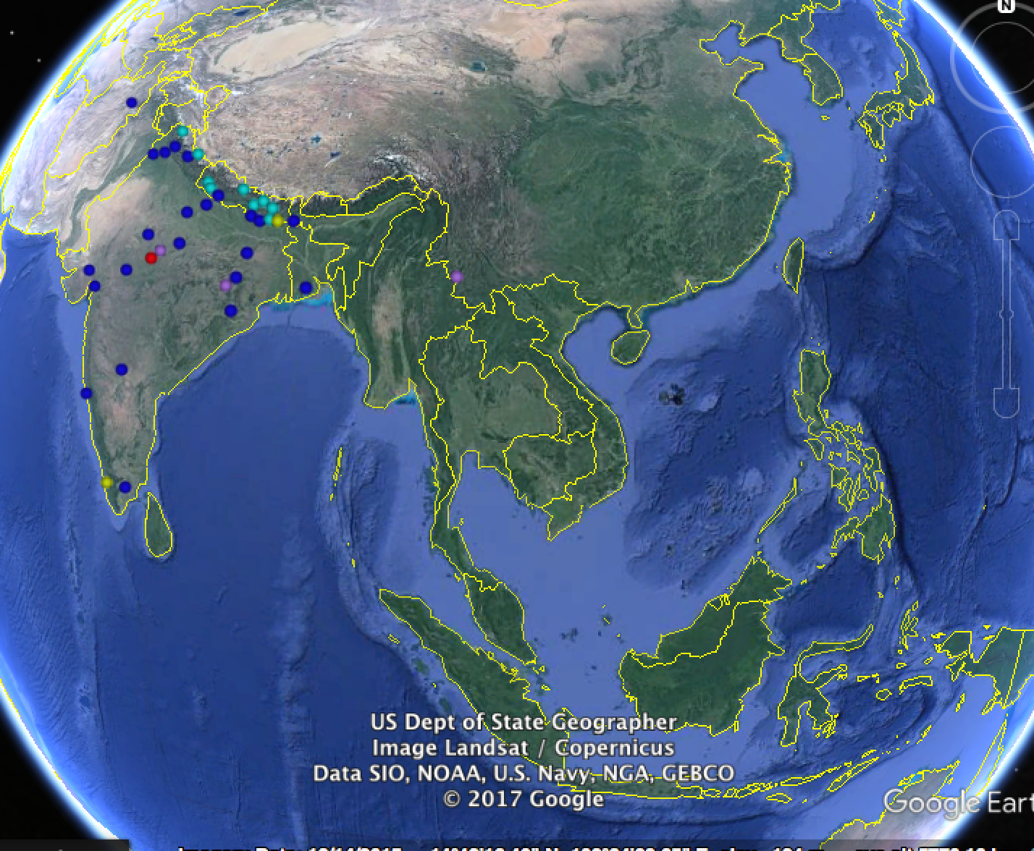

There is another area in India, which is just along the east coast and the south, comprising Dravidian and Austroasiatic languages, as well as a handful of Indo-European languages in the north, and some Andamanese languages (Figure 5).

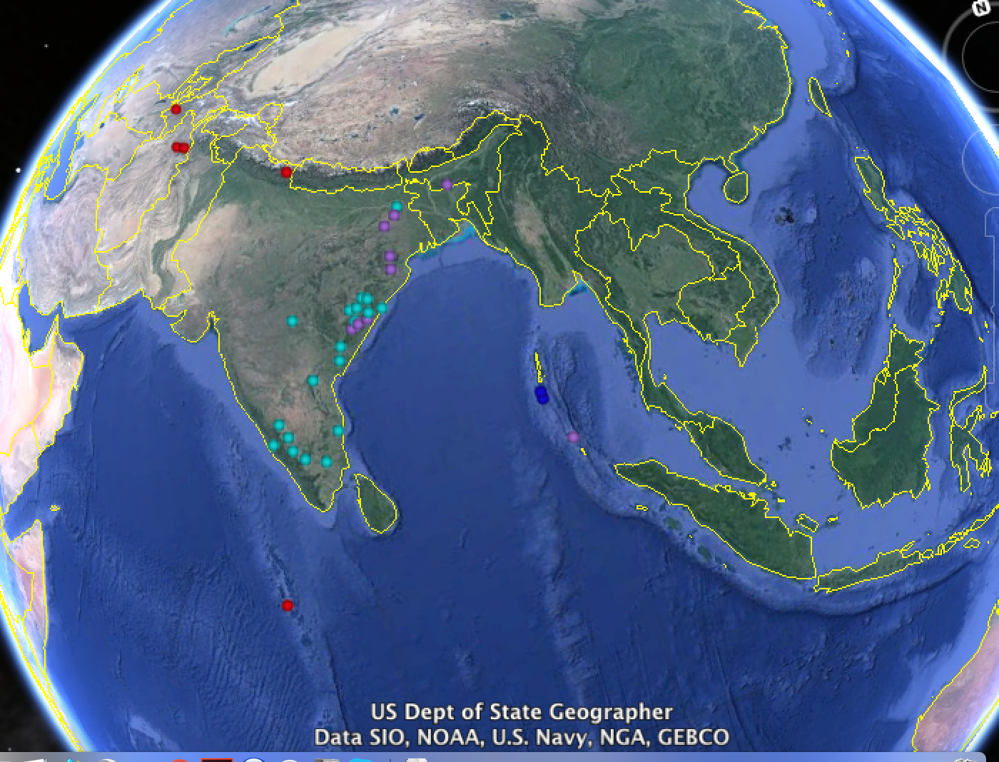

Another cluster is shown in Figure 6, which shows an area of western China that stretches northwards, mainly made up of Sino-Tibetan languages but with some Turkic and Mongolic languages as well.

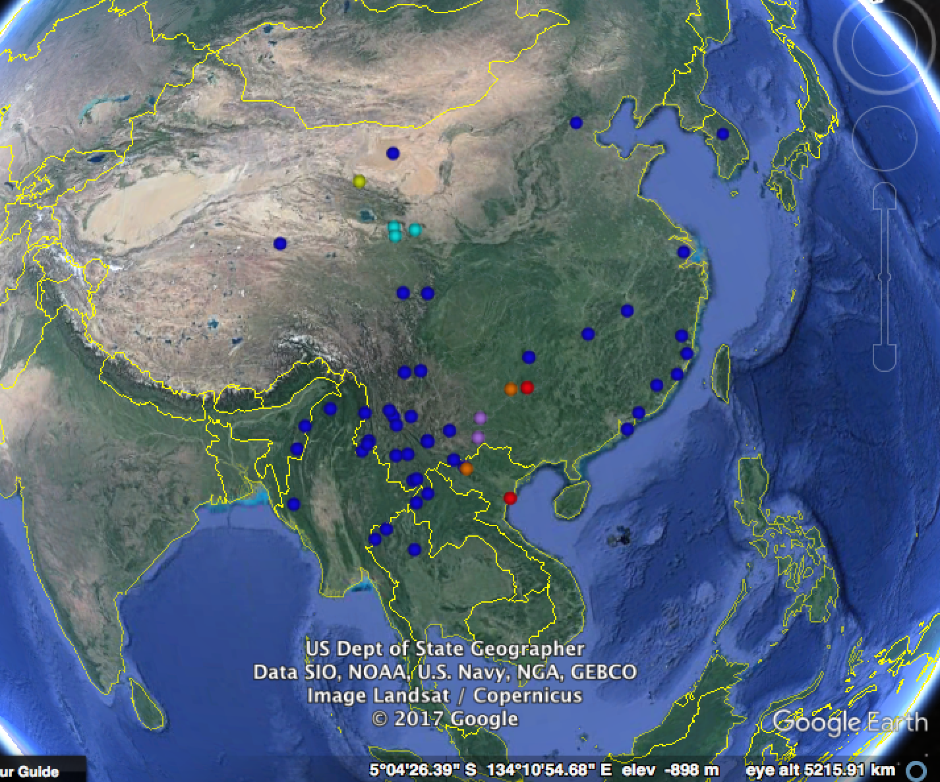

Beyond Southeast Asia, there are some surprising clusters of languages; there is an arc of languages running from the Caucasus through the Arabian peninsula and into Afghanistan and Pakistan (Figure 7). The Caucasus has been written about as a linguistic area (Chirikba 2008), although not as part of a larger area in the Arabian peninsula and south Asia. Again this area is richly structured, such that there is an area within it of just the Caucasus and the Arabian peninsula (29%); and within that, smaller clusters such as just languages in the Caucasus (Kartelian, Nakh-Daghestanian and some Indo-European), a cluster of Arabic dialects, and the Northwest Caucasian languages as a separate cluster.

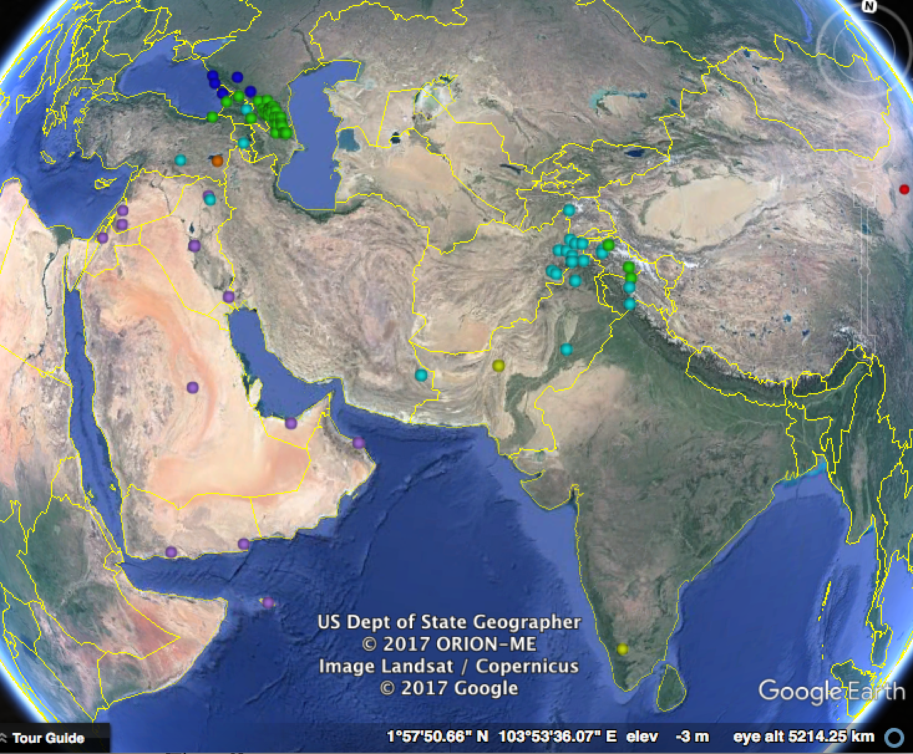

Another surprising, large area covers both Indo-European and Turkic languages, as well as other languages that they have been in contact with (Figure 8).

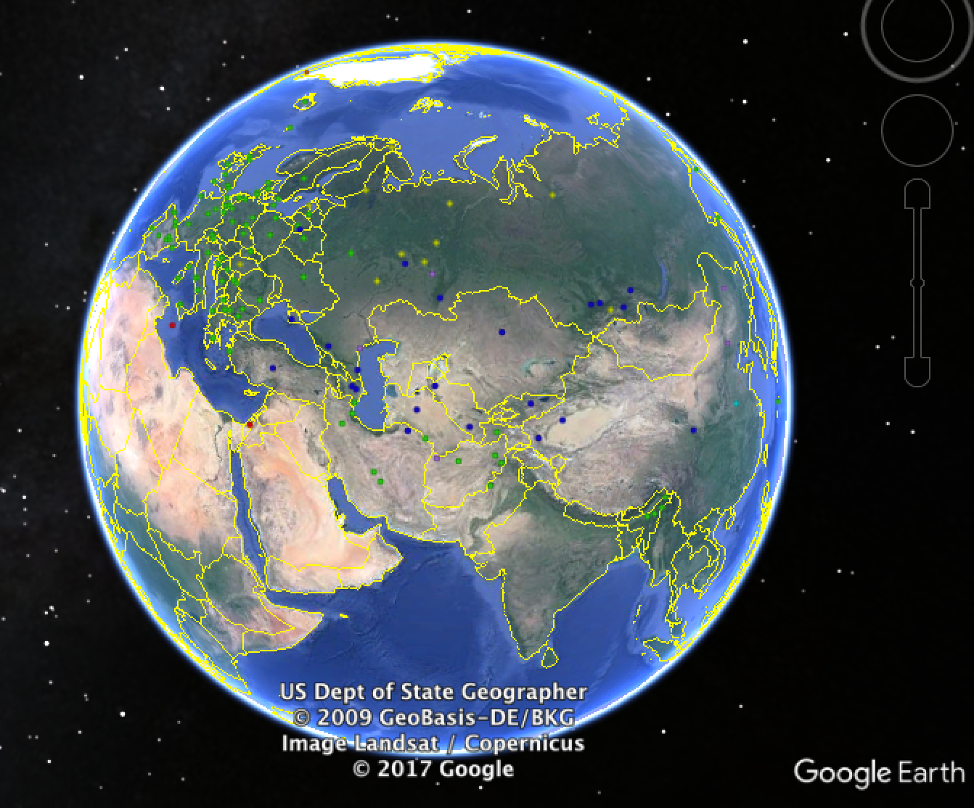

There are other clusters that emerge from this analysis, as well as many local clusters within them, but these better-supported examples show what the method is capable of detecting. Other outcomes of the analysis include a ranking of features by how quickly they change.

The analysis shows that there are some clusters of languages that are structurally similar, and these clusters cross-cut language families. This vindicates the notion of a linguistic area, namely areas where languages have been in contact.

There is a clear problem with the phylogenetic method used. Languages can belong to more than one area, especially if they are geographically located somewhere between them. Languages in the Himalayas for instance may belong to an area in India and an area in Southeast Asia. The phylogenetic method used forces these languages to be placed in a particular clade, and so into just one area. The Bayesian analysis may show which languages are indeterminate (some languages may fit equally well into an Indian clade as they do in a Southeast Asian clade), but multiple membership is not part of the model itself.

Linguists have recognised that languages can be part of multiple linguistic areas (for instance, Matisoff writes of the ‘Indosphere’ and ‘Sinosphere’ in Southeast Asia (Matisoff 1991), but in practice continued to investigate linguistic areas in . There are quantitative methods other than phylogenetics which can deal with multiple membership, such as Latent Dirichlet Allocation which was applied by Dunn et al. (2009) to studying admixture between languages in Island Melanesia. This method does not deal with the problem of non-independence of members of a class, however, or the related fact that it cannot discover clusters within clusters. The strength of a phylogenetic method is that it can discover clusters of multiple layers.

An area for further research is therefore implementing a phylogenetic method that has the strength of a method that allows languages to belong to multiple clusters. At the end of Chapter 2, I suggest a model that can implement this, which is a mixture model that assumes that different structural properties have different histories, as described in Pagel and Meade (2004).

**3. Overview of the Thesis**

The analysis in Chapter 2 demonstrates that there are groupings of languages which are similar in their structures, specifically in what sounds they use, and their phonotactic rules.

The next question is: why are these languages similar? How do languages borrow sound patterns from each other? The hypothesis pursued in Chapter 3 and Chapter 4 is that linguistic patterns are brought by people migrating. This hypothesis is in contrast with a common notion that languages borrow properties from each other simply by virtue of having some bilingualism. It is possible that a feature could be fashionable, for instance.

We could call these hypotheses the demic diffusion and cultural diffusion hypotheses, respectively. This debate is reminiscent of a the debate over how agriculture spread from the Middle East to Europe, which similarly had a theory of demic diffusion in which Near Eastern farmers had a population growth and expanded into Europe, bringing farming with them (Chicki et al. 2002), and a counter-proposal that farming could have been borrowed by neighbouring communities, causing it to spread geographically in a way that does not necessarily involve movement of people.

No doubt both processes may be involved in the spread of linguistic features, but in the particular features under discussion, there is evidence that linguistic features may track the spread of people quite well. Chapter 3 investigates the spread of people according to mitochondrial DNA, using Bayesian phylogeography that has previously been applied to the spread of viruses (Lemey et al. 2009) and languages (Bouckaert et al. 2012). This analysis resulted in a dataset of migrations in Africa and Eurasia in particular

The relationship with language is left to further research, but there are suggestive tendencies such as the way southeast Asia has been relatively isolated from the rest of Eurasia, at least in recent movement (since 12,000 years ago) of maternal lineages. I also show that there are systematic differences in the directions of migration in different regions, and in particular whether people tend to move along the lines of latitude (east-west) or whether they move more north-south. These differences may be behind the formation of linguistic areas, if concerted movement in a region can contribute to linguistic homogenization (such as the Bantu expansion in Africa).

Chapter 4 is a case study of the way that linguistic structures can spread with people. Enfield (2003) describes how Tai people migrated out of southwest China, and this process can be seen in the differences in proportion of Tai speakers in different regions. I survey syntactic and semantic structures of a group of closely related Austroasiatic languages in this region, and show that they are more similar to Tai where there is a greater proportion of Tai speakers nearby. A similar result is obtained when re-using phonological data from Chapter 2, lending further support to the demic hypothesis that linguistic areas are created by migration.

Chapter 5 discusses the history of a particular feature, tone, which is conspicuously associated with language contact in Southeast Asia. This feature is interesting because of its striking geographical distribution, and a few controversial hypotheses that have been proposed to explain it. For instance, Everett et al. (2015) suggested that tonal languages are more likely to be spoken in warmer, more humid environments, due to the effect of humidity on the ease of producing phonation in the larynx. Dediu and Ladd (2007) claimed that tone may be influenced by two genetic markers that it correlates with (variants of *ASPM* and *Microcephalin*). The chapter proposes instead that tone has spread by contact in various regions, creating the illusion of a meaningful correlation with non-linguistic factors. This is shown by simulations in which tone spread in different parts of the world and turns out to be very likely to correlate with humidity, and with genetic variants such as mitochondrial DNA markers.

**Chapter 2: The Family Tree of Sound Systems**

**1. Introduction**

Languages have properties such as syntax and particular sounds that they use which may the history of languages in the way that basic vocabulary does. This is hinted at by the World Atlas of Language Structures (WALS) (Dryer and Haspelmath 2013), which shows that some structural properties tend to predominate in certain areas of the world, for example agglutinative morphology and subject-object-verb order across a large part of Eurasia, or polysynthetic morphology in the Americas.

Nichols (1992) explored this in a statistical way by sampling languages around the world and describing some geographical clustering of properties such as word orders, tone, numeral classifiers and so on. This developed into the AUTOTYP project in 1996 collecting typological information from languages around the world, like projects a few years later such as WALS. Papers using that database such as Bickel and Nichols (2006) argued that certain features occur more often than expected by chance in certain regions, suggesting that these regions are ‘linguistic areas’ in the sense that languages in those areas have some kind of common history.

The problem with approaches like these is that such clustering is hierarchical: there are not simply linguistic areas, there are areas within areas. Local instances of language contact or common ancestry can cause features to be more common in the larger area as well. To control for local clustering, some multi-level method needs to be used, perhaps the most developed of which is phylogenetic methods.

Phylogenetic methods were applied to language structures first by Dunn et al. (2005) on a set of Melanesian and Papuan languages, and found that closely related languages in Melanesia cluster hierarchically in a family tree similar to the tree found by using vocabulary. They also found that unrelated languages in Papua New Guinea shared properties and also formed a family tree, suggesting either ancient relatedness or contact between these languages. Other papers applied these methods to the WALS data, finding some evidence for large-scale clustering that might again indicate macro-families or large-scale contact (Dediu and Levinson 2012, Dediu and Cysouw 2013).

In particular, phonological properties of languages may reveal the history of languages, given that whole language families such as Sino-Tibetan can be tonal (and conversely whole language families non-tonal), or have quite distinctive properties such as clicks. Atkinson (2011) explored the idea that the size of phoneme inventories may be stable, as languages in Africa tend to have large numbers of consonants (for example), while languages in Oceania and South America typically have much fewer. His main hypothesis was that phoneme inventory sizes may display something analogous to founder effects, by decreasing when there are population bottlenecks, and hence that phoneme inventory sizes should decrease with distance from Africa (as they in fact do); the details of that idea will be discussed further in Chapter 5 of this thesis, and is mentioned here only to introduce the notion that features such as the number of consonants may be historically informative. This idea is explored in a phylogenetic way in the remainder of this chapter.

**2. Methods: Bayesian Analysis of the World Phonotactics Database**

The World Phonotactics Database (Donohue et al. 2013) has information for over 3500 languages around the world, for 161 questions to do with phonology and phonotactics (as well as some additional information on population sizes and word order). The questions range from asking how many consonants can maximally appear in the onset or coda of syllables, what kind of consonants can appear in certain positions (e.g. ‘Is the second consonant preferentially a glide?’), question about the number of consonants in the language, and about more specific types of consonant (‘Does the language have rhotics?’, ‘How many coronal nasal places are there?’). The questions therefore are divided between binary questions which have either ‘yes’ or ‘no’ as an answer, and questions which have a number such as the number of consonants in a language or the number of consonants in a coda.

Each language has data on features such as the number of consonants, number of plosives and so on, as well as phonotactic features such as the number of consonants maximally allowed in the onset and coda. There are dependencies between features, both logically (in the sense that some features are more specific versions of other features, such as ‘Are there clicks?’ and ‘Are there dental clicks?’) and functionally (there may be trade-offs in languages in the complexity of different domains, such as tonal languages being less likely to allow complex consonant clusters).

This database has not been analysed using phylogenetic methods before, and so the main focus of this chapter will be on converting this data into a format that can be analysed with these methods, and seeing how much historical signal they contain. The reason for using a Bayesian phylogenetic method is that it is a way of quantifying similarity between languages in their sound systems, whether this similarity is due to common ancestry or language contact. Phylogenetic methods model the way that traits have evolved along family trees, and hence are controlling for clustering at lower levels of the hierarchy; this is in contrast with simpler methods such as those employed by Bickel and Nichols (2006), which attempt to quantify commonalities shared by languages in a region such as the Pacific Rim but do not control for local areality such as in Meso-America. If there are such local clusters, a phylogenetic method would find them (making Meso-America a clade for example), and they would not affect the likelihood of putative higher-order clades such as the Pacific Rim.

The advantages of using a Bayesian approach have been discussed in the introduction with respect to modelling basic vocabulary, namely that these methods are a direct way of finding the posterior probability of trees and hence in quantifying uncertainty about how languages are related. They can also include sophisticated models of how traits evolve at different rates. This analysis will focus on language families in Eurasia in particular, an area that is the general focus of this thesis. The languages under analysis are from the World Phonotactics Database (all languages in the database are given a label for what continent they are on, so this was done simply by retaining languages labelled ‘Eurasia’), comprising thirty-six language families according to the (conservative) Glottolog classification. This includes languages in some language families such as Afro-Asiatic and Austronesian, most of which are found outside of Eurasia (in Africa and the Pacific respectively).

Dependencies are a problem for any Bayesian phylogenetic analysis, because the likelihood of a tree is calculated for each feature and then multiplied to give a total likelihood for the tree. This can only be done if each feature is statistically independent. In practice, it is not clear how much dependencies affect the result of analyses. In addition, there is no easy way of getting rid of them in this data, as both general features (‘Are there clicks?’) and more specific features (‘Are there dental clicks?’) may both carry historical information. Functional dependency is also difficult to get rid of, both because phonological systems may have a large number of complex dependencies between features, making them difficult to get rid of entirely, and also because there is no easy statistical way of distinguishing features that correlate in languages because of functional dependency and those that correlate because of shared inheritance and contact. One possible way of disentangling the two is to run the phylogenetic analysis here, and then use the resulting phylogenies to test for the correlation between different features. The correlation test would be the same as that used to test word order correlations by Dunn et al. (2011), which takes known family trees and then tests models for how features co-evolve (namely whether some combinations are favoured over others). For now, the test was run treating features as independent.

An additional analysis was run using a methodological innovation due to a forthcoming paper by Maurits et al., which is to use known language phylogenies as monophyletic clade priors. The purpose of doing this, as Maurits et al. write, is to be able to find out which features change quickly and which change slowly. It also constrains the search space to make the analysis run more quickly, as without any constraints at all an analysis of several hundred languages can become stuck in local optima (that is, it finds a set of trees which have relatively high likelihood and hence it is unable to move away from them to find trees in another part of the tree space which also have a high likelihood). To implement this the family tree classification from Glottolog was used (Hammarström et al. 2014). Each grouping and sub-grouping in the Glottolog family tree was used as a monophyletic clade constraint (e.g. Indo-European, Germanic, North Germanic, etc.).

The Markov Chain Monte Carlo analysis was run for 10 million iterations in each analysis, with a burn-in of 1 million iterations. The effective sample size is small (4),The analysis was also run a second time incorporating the geographical positions of languages. The spherical geography package of BEAST 2 allows of how languages have been moving, using a model where location is a continuous variable that evolves by Brownian motion along the tree (Lemey et al. 2009, Bouckaert 2015).

A test of how well the method is able to detect vertical inheritance is to rerun the analysis but removing a clade-constraint. I reran the analysis removing the Indo-European clade constraint in order to see whether the method would be able to detect that Indo-European languages are related, and in particular whether sub-groups such as Romance, Germanic, Slavic and so on emerge.

The substitution model (developed by Maurits et al. forthcoming) assumes that phoneme inventories evolve in a step-wise way, being more likely to transition to a number of phonemes that is close by: a transition from 6 tones to 7 or 8 tones should be more likely than transitioning to zero tones.

**3. Results**

The main result is a tree of Eurasian languages, comprising clades with different degrees of support. The full consensus tree is presented in the supplementary materials. Because it is too large to describe in full, a selection of the more strongly supported large clades will be given. The posterior probability is given in brackets, with brief descriptions of the location and main language families.

1. South China (72%), mostly comprising Sino-Tibetan, Hmong-Mien, and a few Tai-Kadai languages. The languages are shown in Figure X, and are coloured to show their language family: Sino-Tibetan in dark blue, Hmong-Mien in red, Tai-Kadai in yellow and Austroasiatic in light blue.

2. India and western Southeast Asia (30%). This group splits into two sub-groups, one in India (100%) and one in Southeast Asia (37%). The group in India is mainly made up of Indo-European and Tibeto-Burman languages. The group in Southeast Asia is mainly made up of Tibeto-Burman languages in the Himalayas, with a few Austroasiatic languages.

3. Indo-European and Turkic languages (64%). This clade splits into two overlapping groups, one primarily Indo-European in Europe, comprising some Slavic and Romance languages (100%). The other group splits in two, one group containing the remainder of the Indo-European languages (45%), and a second group (17%) which contains a Turkic sub-clade (82%) and two strongly supported but strange groups, described in (4) and (5).

4. A disparate group (99%) containing Yenets, Maltese, Greenlandic, Tajik, Romany and Moghol. These may be languages that have been influenced in some way by Turkic languages but not enough for them to be placed with the Turkic languages themselves.

5. Another disparate group (99%) containing Amami Ryukyuan, Nivkh, and two Indo-European languages, Avestan and Waigali.

6. Eastern and southern India, containing mostly Austro-Asiatic and Dravidian (58%). There are also a few Indo-European languages such as Kumauni, suggesting that in some cases Indo-European languages have been strongly influenced by Dravidian. Embarrassingly, Nynorsk (Norwegian) is also included in this clade, reminding us that these results will contain errors and need to be interpreted probabilistically.

7. An arc of languages running from the Caucasus through the Arabian peninsula and into Afghanistan and Pakistan (36%) (Figure X). This group is richly structured, comprising smaller groups such as just the Caucasus and Middle East (29%); just Nakh-Daghestanian and Kartvelian (47%); the Northwest Caucasus (83%); and Arabic varieties along with Kurdish and Brahui (64%).

8. Western and northern China (81%). This group contains a sub-clade of Mongolic, Turkic and northern Sinitic languages (81%), suggesting that languages such as Mandarin have influenced or been influenced by other languages in north China.

These groups are plausible candidates for being linguistic areas, in the sense that they are groups of languages with relatively high posterior probabilities, and are geographically coherent (with the exception of 4 and 5).

There is a lot more to explore in the results, such as the interactions between particular languages and how plausible these interactions are historically. In many cases the analysis recovers groups of related languages, as expected because phonotactic properties are inherited from ancestral languages. But the method is unreliable for reconstructing common ancestry, and does particularly badly in reconstructing families such as Indo-European. Indo-European languages are not placed in a single clade for example, being placed with nearby languages such as in Southeast Asia, the Caucasus, or Uralic languages. Some relationships within Indo-European are suggested, such as among some Slavic languages (40%), but many languages in these groups are otherwise scattered around the tree. Some sub-clades show clear language contact, such as one that contains Basque and Spanish dialects (83%), but many are likely to be simply mistakes, such as a clade containing Greek, Sicilian, Manx and the Chukotko-Kamchatkan language Itelmen (43%).

The following section describes the results of an analysis where the clades are constrained to include known language families. This is to test a hypothesis due to Maurits et al. (forthcoming) that this method can potentially recover macro-families; and in doing so, some clearer results about linguistic areas are also obtained.

**4. Results of the Clade Constrained Analysis**

As with the analysis above, the main result is a tree of Eurasian languages, this time with known language families as clades. Several putative macro-families emerge, with high posterior probabilities. The question is whether these might be genuine macro-families, or whether they reflect language contact. The main results will be summarised here, and suggested to reflect language contact, for reasons explained in more detail below.

The main results are:

1. A clade covering most of Eurasia, in a way that resembles the Eurasian linguistic area of Bickel and Nichols (2006) (85%). This clade covers all language families in the sample except for families of Southeast Asia.

2. A clade covering language families in Southeast Asia (Austronesian, Tai-Kadai, Sino-Tibetan, Hmong-Mien, Austroasiatic, Shompen) (82%). This is less surprising as it corresponds to a well-known southeast Asian linguistic area (e.g. Enfield 2005), although it is gratifying to see this supported in a quantitative way with such high probability, based entirely on phonological features.

3. Within the main Eurasia clade, there is a clade comprising the Caucasus and Afro-Asiatic (94%).

4. This clade is also part of a larger clade (48%) containing various language families in Eurasia, such as Turkic, Uralic, Nivkh, Ket, Chukotko-Kamchatkan, and Eskimo-Aleut.

5. A Turkic-Uralic clade (96%), suggesting recent interaction between these two northern Eurasian families.

6. Within Southeast Asia, there is clade comprising Tai-Kadai, Austroasiatic, Austronesian and Shompen (81%).

Figure 1: The family tree of language families in Eurasia based on phonotactic properties. Numbers on clades are posterior probabilities.

The next question is whether the clades discovered in this analysis could be valid macro-families, namely whether languages in Northeast Asia for example might be related to each other. In order to answer this, the analysis was rerun (without phylogeography) but with the Indo-European clade constraint removed. This was in order to see whether the method was capable of reconstructing the Indo-European language family accurately.

The result was that Indo-European languages were recognised to be related, with most of them present in a clade with 55% posterior probability, but with other families also included due to the effect of language contact. European branches of Indo-European were grouped with Uralic and Basque (also found in Europe), while Indo-Iranian languages mostly were grouped with nearby language families Dravidian, Burushaski and Jarawa-Onge.

Within Europe many clades reflect known subgroups such as Slavic and Romance, but they are also disrupted by language contact again: Basque is placed with Spanish varieties for example, while Greek and Albanian are placed with Romance languages. This seems to show that the method cannot reliably reconstruct common ancestry of languages, at least when common ancestry is defined in terms of vocabulary; for example English and Scots English are placed in different clades despite being very closely related, English being placed with German while Scots English is placed with Icelandic and Faroese, perhaps because of Norse influence. There is a positive result however, which is that common ancestry is detected here: Indo-European languages are generally placed in a clade with 55% probability despite covering a large area from western Europe to Nepal and having phonologically very diverse systems.

The other contribution of this analysis is showing interactions between languages through language contact, such as Greek with the Romance languages, Basque with Spanish, Germanic and Celtic languages, and Indo-Iranian languages with Dravidian, a side of Indo-European history that has largely been unexplored in a quantitative way.

Figure 2: A family tree of Indo-European based on phonotactic properties.

**5. Discussion and Conclusions**

The methods used in this chapter are best seen as a type of cluster analysis. Languages which are similar to each other in their phonology are grouped together, whether the similarities are due to inheritance or contact. Several geographically coherent groups of languages emerge, which can be interpreted as linguistic areas because they cross-cut language families: a South China area; an Indian/Himalayan area; an eastern and southern Indian area; a Caucasus/Middle East area; an Indo-Turkic area; and so on. When clade constraints are added, there is strong support for linguistic areas such as Southeast Asia, and even a large macro-Eurasian area.

The advantage of using a Bayesian phylogenetic method is that it is hierarchical, finding clades within clades. It can be thought of as an automatic way of grouping languages in the way that linguists already do when they propose linguistic areas, but in a way that allows for sophisticated parameters such as different rates of change of features, and controlling for local instances of language contact and relatedness.

The disadvantage is clearly that it forces languages to belong to a particular clade, whereas in reality languages may have more than one parent. The mixed nature of many languages will lead to some strange results in the tree. For instance, one of the disparate groups found in the first analysis (group 4, containing languages as far apart as Maltese and Greenlandic) may be due to some of these languages having been influenced by Turkic. They therefore have some properties in common with each other, but not enough to make them be part of the main clade of Turkic languages. They are therefore forced into their own group, which should be interpreted as reflecting the boundary of a linguistic area rather than an area in its own right.

Similarly, languages in the Himalayas may have structural properties from both India and Southeast Asia (in particular, from Indo-European and Tibeto-Burman). What is needed is a method that can allow languages to have some properties inherited from one tree, and some features inherited from another. The mathematical framework for this method exists, having been described in Pagel and Meade (2004). Gray, Greenhill and Ross (2010) allude to this framework, adding that this method has not been applied to cultural data: ‘We suggest that Bayesian phylogenetic mixture models (Pagel and Meade 2004) could be used to investigate complex histories at the level of specific characters. Instead of forcing all the characters onto a single tree, these mixture models allow different models of evolution to be applied to each character in the data. Essentially this allows the characters to “choose” between alternative trees. A multiple topology mixture model is currently implemented in Bayes Phylogenies (Pagel and Meade 2004) but, to the best of our knowledge, has not yet been used in studies of cultural evolution.’ This remains true at the time of writing in 2018, and the application of a multiple topology model is particularly appropriate for structural data.

Further work can be done on describing the possible origins of linguistic areas. A naive reading of the phylogenies would suggest that the phonological features that define these areas spread out from specific places; for instance, in the clade constrained analysis the northern/western Eurasian area may have originated in the Anatolian region, consistent with claims that Indo-European probably began near there Anatolia (Bouckaert et al. 2011) and with the agricultural origin of many of these families that would point to an origin in that area near the Fertile Crescent (Diamond and Bellwood 2003). Similarly, the southeast Asian area would appear to have originated somewhere in modern Myanmar, where Austro-Asiatic may have originated (according to my own phylogeographic analysis here) and not far from where Sino-Tibetan originated in western China (again according to this analysis). This may again be consistent with an agricultural origin of the southeast Asian area, if linguistic features spread with something like the movement of rice farmers; similarly, the northeast Asian area has an origin in northern China, perhaps corresponding to the spread of millet farming (Bellwood 2013).

The inferred geographical origins of these linguistic areas may be correct, if only because phylogeographic analysis in these cases often gives a geographical centroid. A greater problem is inferring how old these areas are, and hence evaluating hypotheses linking the formation of linguistic areas with agricultural expansions. Some calibrations could be used such as the age of particular families or sub-families, helping to estimate the age of linguistic areas from the amount of structural diversity that accrues within them. Both projects would benefit from using a multiple topology model, rather than assuming a single topology. Despite the current limitations, the statistical support for the existence of these linguistic areas helps to make predictions about the movement of people and cultures which can be usefully compared with migration zones inferred from genetics or archeology.

**Chapter 3: Linguistic Areas and the Prehistoric Migrations**

Linguistic areas emerge wherever languages share common structures, either due to inheritance or contact (again according to the definition employed in this thesis, from Dryer (1992); other definitions require clear evidence of language contact, such as Thomason and Kaufman (1988:95-97)). The previous chapter identified geographical clusters in which languages tend to share phonological properties. This chapter asks how linguistic areas are formed, and whether their existence can be predicted by non-linguistic factors.

A hypothesis explored in this chapter is that linguistic areas are formed by migration of people, for example of Tai-Kadai speakers out of southern China to the rest of southeast Asia. This hypothesis is investigated by phylogeographic reconstruction of mitochondrial DNA lineages. The approach taken is to use a spatial model implemented in BEAST by Bouckaert (2015).

There has not previously been a model-based approach to analysing the movement of people according to mtDNA, which is one contribution of this chapter. The main result is that movement over the last 15000 years has occurred mainly within certain broad linguistic areas rather than between them, in spite of the fact that migration has often been over very long distances, such as across Siberia, or from China into the islands in the Pacific. This lends support to the hypothesis that linguistic areas reflect recent movements of people.

A further analysis of 2000 migrations is conducted, in order to investigate differences in directions of migration in different regions. There are statistically significant differences in the directions that people move, and most strikingly in whether people move horizontally (east-west) rather than vertically (north-south). These tendencies may be behind the shape of linguistic areas discovered in chapter 1.

**1. Introduction**

The previous chapter was about the fact that languages share common phonological properties across language families. The analysis of the World Phonotactics Database showed that languages in Eurasia seem to fall into two main clusters. The first cluster is Southeast Asia, which has been suggested to be a linguistic area by linguists (e.g. Enfield 2005). The second cluster is the rest of Eurasia, covering Europe, most of Siberia, India, the Middle East and North Africa. This cluster will be referred to as ‘Eurasia’ for short for the rest of the chapter.

Why did these areas form? One reason may be because of concerted migration of people across language boundaries, and in particular if people have expanded out of a certain area. Southeast Asia may be an example of this, as certain language families such as Tai-Kadai spread out of southern China to the rest of Southeast Asia, and likely influenced the phonology of languages that they came into contact with while doing so.

This may be viewed as a hypothesis about the ‘demic’ spread of phonological features, namely that movement of people is required for language contact to happen. An alternative hypothesis is that phonological features can spread between neighbouring languages without there necessarily being concerted movement of people. This is often argued by analogy to have happened with agriculture, which can be borrowed between people without there being a genetic signal of agriculturalists moving (Zvelibel 2000), although in practice there is genetic support for the demic model in the case of agriculture, such as in Chikhi et al. (2002).

The demic hypothesis can be tested by looking at genetic data, and in particular at data which shows the structure of a family tree and the ages at which people are related. Mitochondrial DNA (mtDNA) is one such type of data, given that it is inherited from the mother. A phylogeny of mtDNA can therefore be thought of as a family tree of women. This family tree shows the way that people have been migrating around the world, and provides a framework for understanding the history of languages.

There is a large literature on investigating the history of mitochondrial DNA and how long ago particular migration events may have happened (Hasegawa et al. 1985, Kivisild 2015). There are also surveys of the geographical distributions of mitochondrial DNA clades (haplogroups) and proposals of the way that these can be used to reconstruct history (Harcourt 2016) . Perhaps surprisingly, there is not work using model-based phylogeographic reconstruction of the type implemented in software such as BEAST, developed by Lemey et al. (2009) for viruses and since applied to the spread of Indo-European languages by Bouckaert et al. (2012). One aim of this chapter is therefore to conduct such a phylogeographic analysis, to provide a visualisation of mtDNA lineages that would allow some comparison with the spread of languages.

One challenge in this reconstruction is calibrating the molecular clock, which carries a large amount of uncertainty in how quickly it evolves, to the point that different studies find rates with different orders of magnitude (Kivisild et al. 2015, Ho and Duchêne 2016). The approach taken in this chapter is to use calibrations from ancient DNA samples following Rieux et al. (2014). The ages of samples can by themselves provide some information about the molecular clock rate, in ways that should be less subject to disagreement than other assumptions such as the date of divergence between humans and chimpanzees (Hasegawa et al. 1985) or mutation rate based on pedigree studies (Sigurðardóttir 2000, Heyer 2001, Madrigal 2012). An additional problem is the time-dependency of the rate of the molecular clock, namely that the clock seems to speed up in more recent human history (Ho and Duchêne 2016), mainly because it is subject to natural selection. The dates of reconstructed migrations are therefore uncertain, for these and other reasons discussed in the Method section below.

The hypothesis being investigated is that recent migrations (within the time-scale of language family expansions such as over the last ten thousand years) may have shaped linguistic areas, and in particular that migrations should be within linguistic areas rather than between them.

**2. Data sample and methods**

11846 complete mtDNA sequences were downloaded from GenBank, of which 10302 sequences could be assigned a GPS coordinate using the Python package geocoder, from about 620 locations around the world. The locations are unevenly sampled, with some countries such as Japan and the USA having hundreds of sequences, and some areas such as the Solomon Islands having extremely rich geographic information (due to papers such as Duggan et al. 2014).

Sequences with missing data were removed which had fewer than 16,000 nucleotides. Non-indigenous sequences in the Americas were filtered removed to simplify the analysis by using an online program (Haplofind, https://haplofind.unibo.it/new/) to classify mtDNA sequences by haplogroup, and retaining only indigenous haplogroups A, B, C, D and X. Sequences were then sampled randomly by location with a maximum of 97 sequences per location, resulting in 6,028 sequences. These were then aligned in CLUSTALW (which can currently align at most ~6000 sequences). One sequence was sampled per location from these aligned sequences, resulting in 502 sequences. An additional 64 sequences were used from ancient samples in South America (Llamas et al. 2016) to calibrate the molecular clock, as well as two Neanderthal sequences and a Denisovan sequence (Krause et al. 2010).

Different parts of the mtDNA genome evolve at different rates (e.g. Ho and Duchêne 2016). The sequences were divided into five partitions with their own clock and substitution model, using the Cambridge Reference Sequence (Andrews et al. 1999). The partitions were for the d-loop, non-coding DNA, and first, second and third codon positions of the coding DNA. The substitution models used were Generalized Time Reversible with four gamma rates, and a relaxed exponential clock to allow lineages to evolve at different rates.

There is uncertainty around the mutation rates, as different types of study yield different estimates: studies on the number of mutations that occur within closely related individuals (Howell et al. 2003) estimate the mutation rates as being an order of magnitude faster than phylogenetic studies that assume a human-chimpanzee divergence time of five million years (e.g. Hasegawa et al. 1985). In addition, the mutation rate is known to change over time (Ho and Duchêne 2016), perhaps mainly because over longer time-depths there may be fewer mutations than expected because those mutations are removed by natural selection.

The approach taken in this analysis is to use ancient DNA from samples in South America (Llamas et al. 2016), which range in age from 1000-4000 years. Two Neanderthal samples from 48,000-52,000 years ago and a Denisovan from 32,000-48,000 years ago (Krause et al. 2010) were also included. By using humans and hominins from multiple time-depths, it is hoped that the analysis will be able to detect the change in mutation rate over time due to natural selection. This approach follows Rieux et al. (2014), which find reasonable divergence dates for various events in human evolution, such as a divergence time of 4.1 mya for the human-chimpanzee split, 389,000 ya for the human-Neanderthal split, and 143,000 ya for the most recent ancestor of modern humans. The analysis in this chapter does not currently include their ancient samples, which may provide better calibration points in future than just the ancient South American individuals used here.

For a set of mtDNA sequences, one can propose a particular family tree of how they are related to each other and how much change they have undergone, and one can calculate the probability of that tree generating those mtDNA sequences. The program then searches through possible trees and generates a sample, using the Metropolis-Hastings algorithm. This calculation is implemented in the software package BEAST 2 (Bouckaert et al. 2014). The analysis was run for 60,000,000 iterations, with a burn-in of 50%. The package ‘spherical phylogeography’ (Bouckaert 2014) was used to reconstruct ancestral locations of mtDNA lineages, and the results plotted in Google Earth.

In order to explore possible differences in migrational directions in different regions, a larger analysis of 2000 randomly sampled sequences was conducted. This analysis was run without time calibrations, since the aim was to examine directions of movement rather than their timing, and owing to the computational demands of implementing multiple partitions in analysing a data set of that size.

**3. Results**

The main result of this analysis is a model-based reconstruction of human migrations. The time scale is problematic, because it is systematically too young: the time to the most recent common ancestor humans is estimated to be 62,000 ya (49,000-69,000 ya 95% confidence interval), and the divergence time between humans and Neanderthals is estimated to be 132,500 ya (108,000-165,000 ya). This may be because not enough calibration points were used, with most calibrations being within the last 4000 years. Using older samples such as Tianyuan man (~38,000 ya) as Rieux et al. (2014) do may improve the results.

The topology of the tree is geographically coherent, with the Neanderthals and Denisovan as out-groups, and the first splits occurring in Africa and subsequently in Asia. An animation in Google Earth was produced using the app ‘spread’ (Bouckaert 2014) as a visualisation.

The timing of migrations is uncertain, both because of uncertainty in calibrating the clock, and because the analysis only shows how long ago people are related, not when particular migrations occurred. For example, an individual in Madagascar is related to an individual in Vanuatu (tips Madagascar2 and Vanuatu2 in the tree), sharing a common ancestor 13,200 years ago. The lineages are unlikely to have diverged geographically 13,200 years ago however, as the clade they belong to seems to reflect the Austronesian expansion (dated to 5230 years ago, Gray et al. 2009). The coalescence time can provide an upper bound to the date of a migration, and the coalescence time divided by two could provide a mean estimate for when the migration took place (or divided by a larger number to take into account the fact that the migration rate has been increasing in recent history).

Migrations within the last 10,000 years (according to coalescence time) are of particular relevance to this chapter because they were hypothesised to shape the formation of linguistic areas. Migrations dating within this period are plotted on two maps below (Figures 1-2).

Figure 1: A summary of migrations in Southeast Asia from 10,000 years ago to the present.

Figure 2: A summary of migrations in Eurasia and North Africa from 10,000 years ago to the present.

There are several long-distance migrations in this period, such as from Europe to eastern Siberia or Mongolia; the Middle East to North Africa and Europe; or in Southeast Asia, from southern China to Indonesia and the Pacific. A striking result is that there is little recent migration by contrast (at least in this sample) between Southeast Asia and most of the rest of Eurasia.

This is relevant to the hypothesis explored in this chapter, that linguistic areas such as Southeast Asia are formed by migration. There seems to be regular movement within the Southeast Asian area, and within the Eurasian linguistic area, and relatively little between them. This perhaps explains why these areas emerge as distinct clades in the phylogenetic analysis of phonotactics in Chapter 2. The Eurasian area in blue covers a large area from North Africa (the linguistic area from Chapter 2 includes Afro-Asiatic) to Siberia, within which there has been plenty of recent gene flow.

As a visualisation of this point, the mtDNA migrations are plotted against languages in red in the Southeast Asian area, and languages in blue in the Eurasian area (Figures 3-4). All migrations take place within these areas rather than between them, such that if the nearest language to a point at the beginning of a migration is red, then the nearest language to the point at the end of a migration will also be red. There are two exceptions which are both migrations to India, a meeting point of the two areas.

The absence of migrations detected between Southeast Asia and the rest of Eurasia does not mean that it did not occur; the sample size is small in this analysis (569 individuals, one per distinct location), and the method only detects migrations of the tiny fraction of mitochondrial lineages that have survived to the present. It is still informative however, as it suggests that many people in Southeast Asia are related on the maternal line in a way that they are not with people in northern or western Eurasia, suggesting a comparative lack of recent gene flow between them. This may have contributed to the formation of distinctive linguistic areas in Southeast Asia and Eurasia.

Figure 3: A comparison of mtDNA migrations in Southeast Asia and the languages in red identified as belonging to the Southeast Asian linguistic area in Chapter 2.

Figure 4: A comparison of mtDNA migrations in Eurasia and North Africa and the languages in blue identified as belonging to the Eurasian linguistic area in Chapter 2.

The larger analysis of 2000 sequences allows this point to be quantified further. The consensus tree that was generated has locations reconstructed at each node in the tree. A migration in the tree is defined as a movement from the location of an ancestral node to the location of its immediate daughter, yielding 4,318 distinct migration pathways.

The directions of these migrations differ across regions, and in particular, whether they are along a horizontal east-west axis. The angle that a migration is at relative to a line of latitude can be calculated, and this angle differs on average in different places. To visualise this point, I show squares where there are more migrations below 25 degrees, and squares where migrations have been above 25 degrees. Each square contains thirty migrations, and the cut-off point for statistical significance is 67% (the proportion above which there is a less than five percent probability of there being an equal probability of movements above and below 25 degrees).

Africa and Eurasia are again shown here in particular. Regions where migrations have tended to be more horizontal (less than a 25 degree angle from the latitude line) are shown in Figure …, while regions where migrations have tended to be at more than a 25 degree angle from the latitude line are shown in Figures … - ….

There are some suggestive tendencies which may be behind the formation of linguistic areas found in Chapter 2. There is a tendency for horizontal movement across the Himalayas, for instance, which may be behind the linguistic areas crossing from India to Southeast Asia. Another area contained Indo-European and Turkic, an area which covers a large distance from east to west, in line with the tendency for there to be concerted horizontal movement in the region between Europe and northern China. Finally, the crescent of languages from the Middle East and the Caucasus to northwest India is also seen here, since there is a tendency for horizontal movement in this region.

There are also some striking areas where vertical movement (at a greater than 25 degree angle) has predominated. This is most true in Africa, where the angles of migrations have tended to be above 45 degrees, mirroring the southern expansion of Bantu languages. It is also true in island southeast Asia, probably due to the Austronesian expansion; and in China and southeast Asia, where several vertical clusters of languages were discovered in Chapter 2 based on similarity of phonology. This is plausibly driven by the expansion of particular families, such as the southern movement of Tai-Kadai speakers out of China to the rest of southeast Asia (Enfield 2005).



Figure …: Regions where there is a significant tendency for migrations to be move along latitude lines horizontally (less than 25 degrees).

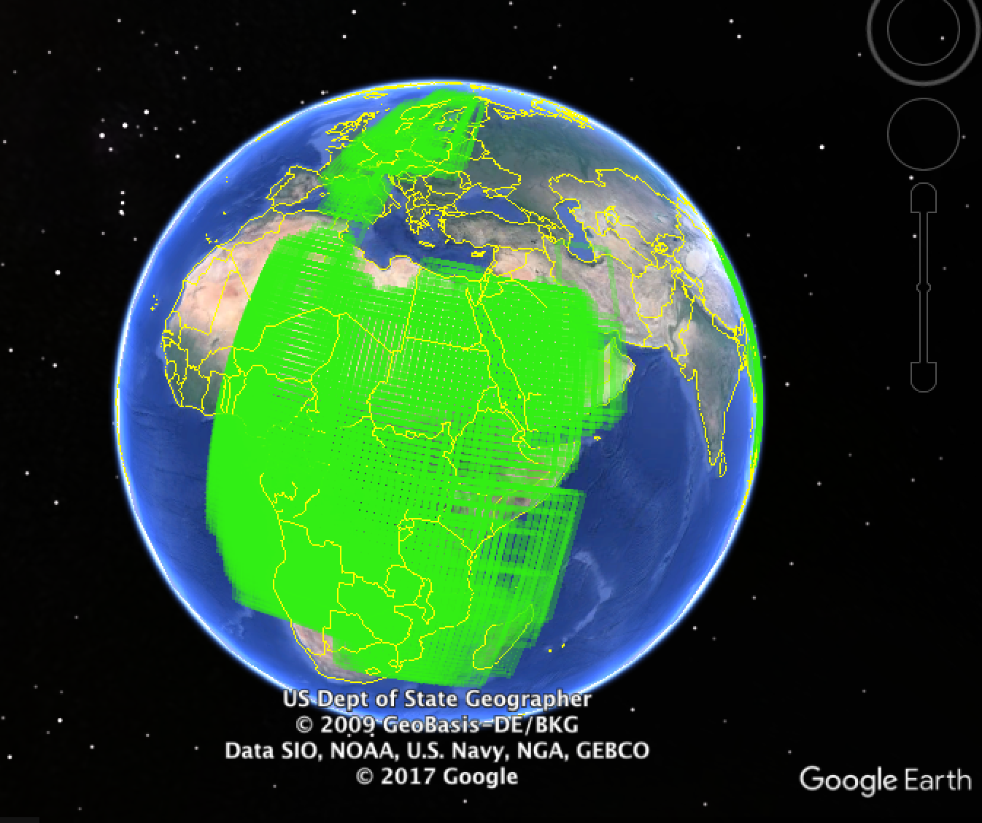

Figure …: Regions where there is a significant tendency for migrations to be move along latitude lines more vertically (more than 25 degrees).

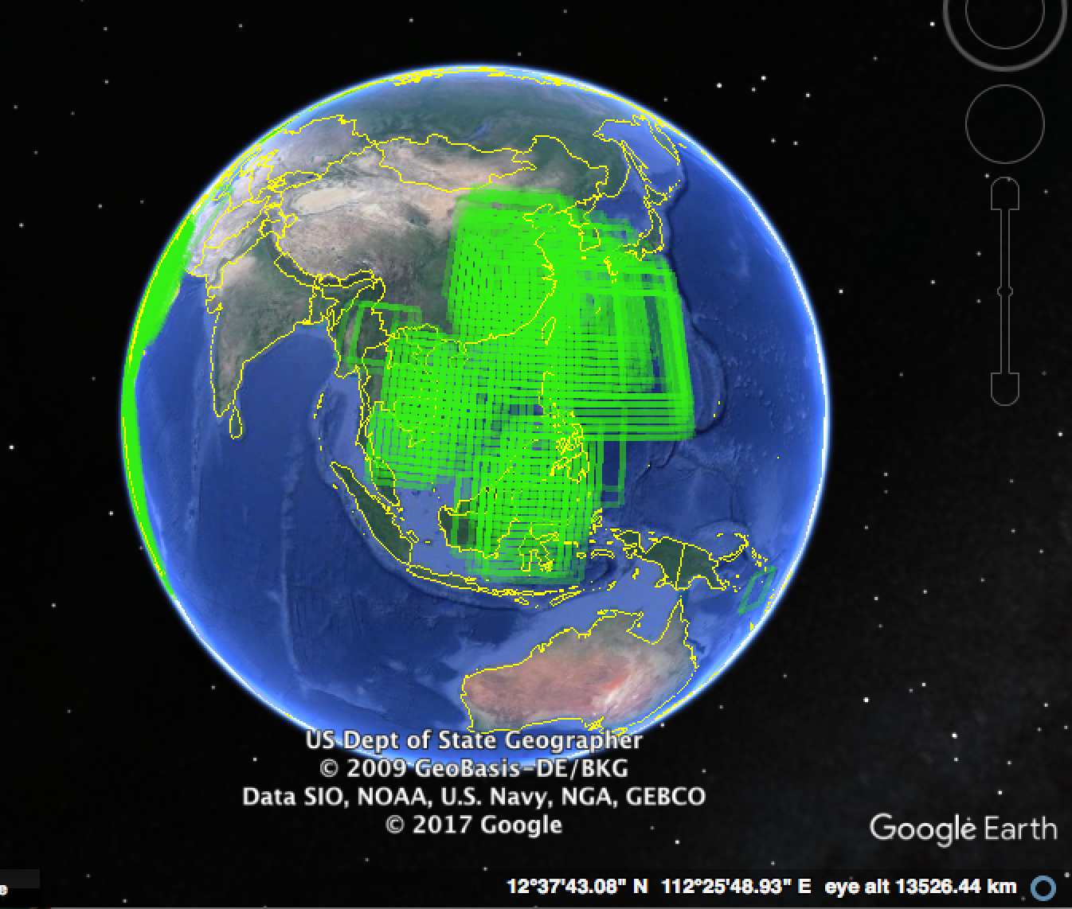

Figure …: (continued) Regions where there is a significant tendency for migrations to be move along latitude lines more vertically (more than 25 degrees).

The regions shown in these three figures are suggestive, since a tendency for concerted movement in particular directions (east-west, or north-south) may be what drives the linguistic homogenisation of some regions. A mass migration southwards in southeast Asia, for instance, may be detectable both from genetics as a statistical tendency to move in a particular direction (southwards, at a greater than 25 degree angle), and also from linguistics, from the similarity of languages in this region in their structural properties.

**5. Conclusion**

The two main linguistic areas identified in Chapter 2 were Southeast Asia and Eurasia, which are defined by similarity in linguistic features from the World Phonotactics Database. The hypothesis was that this convergence may have happened because of a demic spread of phonological properties through these areas. This makes the prediction that there should be migration within these areas that happened recently (for example within the last 10,000 years, in keeping with the time-scale of known language families and agricultural expansions, c.f. Bellwood 2013).

An additional finding in this analysis is the relative isolation of Southeast Asia from the rest of Eurasia, at least from the recent migration of mtDNA lineages. This may have been helped by natural barriers such as the Himalayas, although further back in time there is plenty of migration between Asia and the rest of Eurasia suggesting that this may not have been the main reason. Nor is it due to lack of recent long-distance migration, as in many cases comparable distance are crossed such as from Europe to eastern Siberia; China to the islands of the Pacific; or the Middle East to Europe and North Africa. As shown in the larger analysis of 2000 sequences, there are also systematic differences in the direction that people have moved in different regions, such as southern movements in Africa and southeast Asia, or east-west movements between Europe and northern Asia, or from the Middle East and the Caucasus to northern India.

These migrations have plausible correlates with events such as the spread of agriculture from the Middle East to North Africa and Europe (Bellwood 2013), and the spread of language families such as Austronesian (spanning the Pacific) or Uralic and Turkic (spanning Europe and northern Eurasia). Events where there has been concerted migration associated with agriculture in these cases may have been enough to create a relative imbalance of gene flow, and maintain linguistically distinctive areas.

**Chapter 4: A Case Study of Language Contact in Austroasiatic Languages of Southwest China**

Southeast Asian languages form a linguistic area, in the sense that they share properties which set them apart from other languages in Eurasia which are either due to inheritance or through language contact. This was demonstrated statistically in Chapter 2 using phonological data, but has also been observed to be true of other typological features, such as subject-verb-object word order, numeral classifiers, and various semantic calques (e.g. Enfield 2005).

How did Southeast Asian languages come to share these properties? This chapter surveys a small group of languages in southwest China to show how this process of convergence may have happened, in the East Palaungic branch of the Austroasiatic family. Although the languages are closely related and within a few hundred kilometres of each other, they vary in many of the features that vary in Southeast Asia more generally, such as word order, the use of numeral classifiers, the semantics of verbs, and their phonology. The group of languages is therefore a useful case study of language contact in action.

A particular hypothesis is tested, that the variation in these languages is due to influence from Tai-Kadai languages. This is borne out by an analysis of their phonology from the World Phonotactics Database, and also in the semantic and syntactic features surveyed in this chapter. In addition, the degree of Tai influence on each language shows a geographical pattern, and also a correlation with the proportion of Tai speakers in each area, and the degree of Tai religious influence in the use of Buddhist temples and the erosion of Wa animistic culture.

This suggests a way that Austrosiatic languages more generally came to resemble other languages in Southeast Asia, given that rare features in Palaungic languages are found sporadically elsewhere in Austroasiatic; and suggests a particular process of language contact, namely Tai-Kadai people moving into an area and introducing new features into languages already present there.

**1. Introduction**

I conducted fieldwork on fourteen closely related languages in the area along the border between China and Myanmar, all in the East Palaungic branch of Austroasiatic. These fourteen varieties are dialects of approximately five languages in Glottolog (Hammarström et al. 2014): Nuclear Wa [wbm], Awa [vwa], Blang [blr], Hu [huo] and U [uuu]. Nuclear Wa, Awa and Blang are in the Waic branch, while Hu and U are in the Angkuic branch. The language affiliation of each variety is based on my elicitation of basic vocabulary and comparison with Paul Sidwell’s database of Austroasiatic vocabulary (Sidwell 2015), and using the names given in Glottolog.

These languages were chosen because they are on the boundary of the southeast Asian area, as surveys of the geographical distribution of each linguistic in this chapter will show; on the one hand they are part of the Austroasiatic family, which has unusual values for these features especially further west near India; and on the other hand they are spoken near Tai-Kadai and Sino-Tibetan languages, and hence are likely to be subject to language contact.

These factors make the East Palaungic languages a good case study in how languages can change by language contact. These languages turn out to vary in these features in a way that relates to their geographical location, the proportion of Tai-Kadai speakers in the region, and the presence of another Tai cultural feature, Mahayana Buddhism. This suggests that these languages have been changing in these features due to contact with Tai speakers, and in particular suggests a demographic model as argued in Chapter 3, that language contact happens because of movement of people into a region.

The East Palaungic languages are a branch of Khasi-Palaungic, itself a primary branch of Austroasiatic (other primary branches including Aslian, Nicobaric, Mundaic, Vietic, Khmeric, Khmuic, etc.). The languages surveyed in this chapter are split between two branches, Waic and Angkuic, and have the following tree structure.

Figure 1: A family tree of the varieties surveyed in this chapter

A map of the varieties is shown below using Google Earth (see appendix for the locations and coordinates), as is used for the maps in the rest of this chapter.

Figure 2: A map of the varieties surveyed in this chapter

There are various other languages spoken in this region, including varieties of the Tai-Kadai language Tai Lü (henceforth referred to as Tai) and the Tibeto-Burman language Hani. Census data is available for major towns in the region, and shows that in some places in the east and far north Tai speakers are in a majority (Jinghong, Menghai, Dehong), while in the west near Myanmar it is speakers of Palaungic languages that are in the majority (primarily Awa), such as Ximeng and Cangyuan.

The proportion of Tai speakers to speakers of the relevant East Palaungic language is shown on the map below as ratios. Red locations are where Tai speakers are in a majority, and blue locations are where they are in a minority.

Figure 3: Ratio of Tai speakers to speakers of the relevant East Palaungic language in major towns

In line with the differing numbers of Tai speakers in each region, there are also striking cultural differences between these places, with Tai-style Buddhist temples being mainly found further east such as in Bada, Zhanglang and Mangjing; while traditional Wa symbols such as the bull skull is used on clothes and buildings further west, such as Ximeng, Wengding and Gongxin, and to a lesser extent on roofs in Mangjing (from own observation, but also discussed in surveys such as Miller 2011).

The proportion of Tai speakers in each location predicts the degree to which East Palaungic languages have acquired Tai linguistic features, as shown in the following sections.

2. Features surveyed in East Palaungic languages

This section surveys a series of features in these languages which show variation and may be due to contact with Tai-Kadai languages; word order (2.1), the semantic calque ‘eye of the day’ (2.2), verbal semantics (2.3), the order of modifiers (2.4), and numeral classifiers (2.5). Each section discusses the variation in these features in southeast Asia, and then their variation within the East Palaungic languages.

2.1. Order of Verb, Subject and Object

One of the defining features of the Southeast Asian linguistic area is the use of Subject-Verb-Object (SVO) word order (Enfield 2005, Gil 2013). This is shown in red on the map below from Dryer (2014). Five language families in mainland Southeast Asia and parts of Indonesia use this word order but are surrounded by languages of the rest of Eurasia which tend to use Subject-Object-Verb (SOV) order shown in blue. To the east are the Austronesian languages which tend to use Verb-Subject-Object (VSO) or Verb-Object-Subject (VOS) order, shown in yellow. These word orders cross language family boundaries, suggesting that they have been spreading partially by language contact. For example, Sino-Tibetan and Austroasiatic languages near India use SOV word order, while in China and Southeast Asia they are more likely to use SVO word order. The fact that several neighbouring language families in Southeast Asia use SVO word order also suggests that there has been a spread of this word order through these families, although it may be independent development or inheritance from a common ancestor further back in time as well.

Figure 4: Map from WALS showing the order of subject, verb and object in southeast Asia (blue = subject-object-verb, red = subject-verb-object, yellow circle = verb-subject-object, yellow diamond = verb-object-subject, grey = mixed word orders).

East Palaungic languages are unusual (even unique, based on the points in this map) in mainland Southeast Asia and eastern Eurasia as a whole in using VSO word order. However, there are some interesting indications in the rest of Austroasiatic that this word order may once have been more widespread. Nicobarese, an Austroasiatic language of the Nicobar islands (Dryer 2014), uses VSO order, and some languages in the Aslian of the same family have been described as having some verb-initiality (Kruspe 2004). Most relevant is Khasi, an Austroasiatic language in northeastern India that is most closely related to the Palaungic languages (according to Glottolog and Sidwell 2011). This language also displays VSO order in some clause types (Rabel 1961).

Austroasiatic languages to the west near India therefore show some signs of verb-subject order, while further east they have subject-verb order. One hypothesis is that subject-verb order has been spreading in Austroasiatic due to the influence of Tai, Sinitic and other mainland Southeast Asian languages, while VSO order may have been much more widespread in the past in Austroasiatic languages.

It turns out that Wa languages are an ideal case-study in the spread of SVO word order, as they are split in their use of VSO order and SVO word order. I elicited the intransitive sentence ‘I eat rice’ (‘eat rice’ is a single morpheme) to illustrate variation in the order of verb and subject. Languages which use SV order are shown in red on the map below. Languages which use VS order are shown in blue, and one language which uses both order simultaneously, SVS, is shown in purple. A transcription of ‘I eat.rice’ is shown for each variety as an example, although the same word order also applies to transitive sentences elicited (such as ‘I eat beef’).

Figure 5: Map of verb-subject order in Palaungic languages (red = verb-subject, blue = subject-verb, purple = subject-verb-subject).

Palaungic languages are divided between those which use verb-subject order, shown in blue on the map, and those that use subject-verb order shown in red. One language, Wengwa shown in purple, uses both at the same time (ə ʃɔm ə ‘I eat I’), as if there is a person agreement system. This case is discussed in more detail in section 4 as an example of language contact in action, a case of a dialect that is undergoing a word order change that its immediate neighbours have already completed.

The fact that there is a neat geographical split in the use of these word orders, and furthermore that the variety that uses both simultaneously is found in between them, suggests that subject-verb order has been spreading in these varieties by contact with Tai languages. This can be shown by comparing the distribution of these word orders with the proportion of Tai speakers in each region. The map below shows the word orders (red for SV order, blue for VS order) compared with places with a Tai majority (red) and a Tai minority (blue). Languages with SV order are more likely to be found near points where census data shows a greater number of Tai speakers, in line with this hypothesis.

Figure 6: A comparison of word order with the proportion of Tai speakers in each location.

2.2. Eye of the day

Some languages in Southeast Asia express the word ‘sun’ as ‘eye of the day’, for example the Thai da wan (eye-day) and the Indonesian mata-hari (eye-day). Urban (2010) showed that this semantic pattern is cross-linguistically rare, not being found outside of Southeast Asia and the Pacific where Austronesian languages have brought it. Given that it is widespread in Malayo-Polynesian languages, it may have been present in Malaysia about 3000 years ago (Gray, Drummond and Greenhill 2009), and Urban suggests that it was transmitted into Malayo-Polynesian from mainland Southeast Asian languages.

Figure 7: The global sample for Matthias Urban’s study on ‘eye of the day’ (Urban 2010).

Figure 8: Urban’s (2010) map of ‘eye of the day’ in southeast Asia and Oceania.

However, it is also very prone to being borrowed, for example appearing in several Papuan languages that have had contact with Austronesian. It is a calque found in Tai-Kadai languages in particular, while Austro-Asiatic languages are divided in whether they have it.

Wa varieties again turn out to be a good illustration of the way that the calque can spread by language contact. There is a split in whether they have this feature, and this feature is principally found in the southern varieties close to Tai in Jinghong. Tai also has this expression, da wan ‘eye [of the] day’.

The Wa varieties are split between those which have sŋi or a cognate such as hŋi, ŋi or ŋʌi, meaning ‘sun’ or ‘day’, and those which have ŋʌi sŋi ‘eye of the day’. One complication is that ŋʌi ‘eye’ itself may be etymologically related to ‘sun’ sŋi, perhaps by some derivational process of adding s- as a prefix.

Figure 9: ‘Eye of the day’ in the Palaungic languages (red = present, blue = absent).

Languages with the calque ‘eye of the day’ are shown in red, while languages with a monomorphemic word for ‘sun’ are shown in blue.

Perhaps another example is the word for 'rainbow', which in several of Palaungic languages is 'drink water', niə rɔm, which was explained by informants to refer to a dragon in the sky drinking water. It resembles the expression for 'rainbow' in Thai, รุ้งกินน้ำ roong gin naam 'rainbow drinking water'; and also the word for 'rainbow' in the Tibeto-Burman language Naxi mɯ ɕi dʑi t’ɯ ‘sky tongue drink water’. This was not plotted on a map because informants in most locations did not know the word for ‘rainbow’, but is mentioned as a topic for further research.

2.3. Semantics of ingestion verbs

Semantic typology is relatively understudied compared with syntactic typology, perhaps because there is a large number of grammatical descriptions of languages that tend to include information such as word order, but not detailed descriptions on how for example verbs are used. This might reflect a general lack of awareness of how much words can vary in meaning between languages in even quite basic and concrete domains. Work by Majid, Boster and Bowerman (2008) pioneered the use of standardised elicitation tasks to find out the semantic ranges of ‘cut’ and ‘break’, and showed that languages can partition the semantic space of these verbs very differently. While eliciting verbs for ‘eat’ and ‘drink’ among informants, I occasionally received impatient answers when asking whether the ‘eat’ verb (e.g. ‘eat beef’) could be used with liquids as well (‘eat water’) - ‘No, “eat” means “eat” and “drink” means “drink”.’

This apparently straightforward distinction between eating and drinking can vary in complex ways between languages (Newman 2009). In particular, several languages in southeast Asia allow the main verb ‘eat’ to be used with liquids, such as Thai and other Tai-Kadai languages, some Sinitic languages in Shanghai and Fujian, and some Austroasiatic languages such as Khmer and Minor Mlabri, suggesting that it has been spreading by language contact. Other Austroasiatic languages by contrast often have complex ‘eat’ verbs, such as the Aslian languages which make quite specific and obligatory distinctions such as between eating vegetables and eating meat (Kruspe 2004).

In Wa varieties, it turns out that variation in the semantics of these verbs is even more complicated than expected. I elicited ingestion verbs for nine nouns: rice, beef, fruit, vegetables, congee, soup, alcohol, tea and water.

These verbs were elicited by asking in Mandarin how ‘eat/drink’ was used with these different direct objects. The simplest system is if there is a single verb that is used with all of these, as in the language U in Dabangxie. This can be represented schematically by the table below, which colours all of the nouns in the first column blue, showing that they take the same verb. In another variety in Ximeng according to one informant, there was a distinction between ‘eat’ (for solids such as beef, fruit, vegetables and congee), ‘drink’ (for liquids such as alcohol, tea and water) and a separate verb for ‘eat rice’ and another verb specifically meaning ‘drink soup’. This is represented in the second column by colouring these nouns with four separate colours according to the verb that they take. The third column shows a different informant from Ximeng, who used a specific verb for ‘eat congee’ and a different boundary for ‘eat’ and ‘drink’ than the first informant.

Figure 10: Simple systems of partitioning ingestion verbs in Palaungic languages.

There are many further systems of dividing up the semantic space of these verbs. Some examples of these are given in figure 10 and are plotted on the map in figure 11. White cells are for missing data, in many cases because the informants did not know how to translate the names of particular types of food such as congee.

Figure 11: More complex partitions of ingestion verbs in Palaungic languages, with specific verbs for ‘drink tea’ (yellow, in Gongxin) or ‘eat meat’ (pink, in Zhanglang).

Figure 12: The geographical distribution of different ingestion verb systems.

Despite the diversity of these systems, there are clear recurring tendencies such as solids being grouped together, but also for some food stuffs such as rice, congee and vegetables to be treated as on the borderline between solid and liquid. Below is a table summarising the probability of two nouns taking the same ingestion verb across the different systems elicited.

Figure 13: The probability of a verb for one noun being used with another noun (e.g. ‘eat fruit’ has a probability of 0.46 of being used with ‘eat congee’).

The word for 'eat' kʰʌi in Hu is the same as the word for 'rice' in the other Angkuic language U. This may reflect a tendency in Austroasiatic languages to derive verbs from nouns, such as the verb ‘drink’ from the noun ‘water’ in Mlabri (Rischel 1995). We also saw this in Zhanglang, where ‘I eat meat’ is expressed as ‘I meat meat’, using the noun bɔn as both a noun and a verb.

The use of verbs for specific kinds of eating is found in other parts of Austroasiatic such as the Aslian languages (e.g. Jehai, Burenhult 2005) and Mlabri (Rischel 1995), suggesting that it might be quite an old feature of the family. The simplification of these systems in some languages, such as the Angkuic languages Hu and U, may have been due to contact with Tai (which like Thai only has a single verb covering 'eat' and ‘drink').

2.4. Modifier word order

The word order of modifiers varies in southeast Asia, including adjectives, numerals and demonstratives, but for all of those there is a tendency for the modifier to be placed after the noun. This is especially true in Tai-Kadai languages, and more mixed in Austroasiatic languages. An example of this geographical distribution is shown in the map from WALS below (Dryer 2013), showing the order of demonstrative and noun.

Figure 14: The ordering of demonstrative and noun in languages of southeast Asia and surrounding areas.

The East Palaungic languages all have noun-adjective order, and generally also use noun-numeral order (except when a numeral classifier is not used, as discussed in section 5). The main variation is in demonstrative-noun ordering, where varieties that use noun-demonstrative order are again found in regions with more Tai speakers, suggesting that they have been influenced by noun-demonstrative order in Tai.

Figure 15: The ordering of demonstrative and noun in East Palaungic languages, using the sentence ‘this/that man’ as an example.

2.5. Numeral classifiers

Numeral classifiers are another prototypical feature of southeast Asian languages, which extends into Austronesian languages and even into languages in west Papua (Gil 2013).

East Palaungic languages tend to use numeral classifiers, but vary in the complexity of the classifier systems. A set of about 73 nouns were used to elicit phrases of the form ‘one person’, ‘one dog’ and so on (the full list and data are provided in the appendix), designed to find classifiers for specific categories such as animals, vehicles, long or flat objects, plants, and the like.

The number of classifiers in this elicitation take used ranged from 10 to 24, plotted on the map below (with the three languages in red being the languages with the most classifiers). The geographical pattern is not obvious, but is the same as the map of ‘eye of the day’ above, suggesting that languages with some contact with Tai are likely to have more classifiers. Tai itself as spoken in Jinghong uses 27 classifiers for the same task.

Figure 16: The number of numeral classifiers in each of the seven sampled languages (with the three highest numbers shown in red).

An interesting grammaticalization pathway was noticed in the Angkuic language U in Bangxie (which uses 22 classifiers). The numeral ‘one’ in this language (and its relative Hu) seems to be derived from the general numeral classifier mu in other languages, while the other languages in the sample use dɛ. This affects the ordering of the numeral and the classifier in U: if a classifier is used which is not mu, such as do for animals, then the order is noun-numeral-classifier:

(5) so mu do

dog one classifier

‘one dog’

If the classifier used is mu itself, then the construction is the noun followed by ʌmu:

(6) mɔk ʌmu

hat one.classifer

‘one hat’

The grammaticalization pathway of numeral classifier > ‘one’ is unusual but is found in some Sinitic languages of southeast China, such as Shaowu (Ngai 2015), and so may be a more widespread tendency in southern China more generally. Like ‘eye of the day’, it may therefore turn out to be a good example of a linguistic meme that indicates contact between languages, pending further data on its geographical distribution.

3. Phonology

This chapter has thus far been concerned with showing how particular structural properties can spread through a group of languages by language contact. Examples of features showing contact with Tai are the complexity of numeral classifier systems, semantic calques such as ‘eye of the day’, reduction of complexity in ingestion verb systems, and subject-verb word order.

The overlap of Palaungic languages with Tai-Kadai languages in this region suggests a way of explaining the unusual variation in Palaungic languages. The Angkuic languages Hu and U have properties of Tai-Kadai, such as the expression 'eye of the day' for 'sun', more complex numeral classifiers, fewer 'eat' verbs, and subject-verb order. 'Wa' languages by contrast (Nuclear Wa and Awa) use a single morpheme for 'sun', have fewer numeral classifiers, some specific eat or drink verbs, and verb-subject order, and in these ways seem to preserve properties that are found in other parts of Austroasiatic. Blang is intermediate, using subject-verb order, complex numeral classifiers, and the expression ‘eye of the day’, but at the same time having more complex ‘eat’ verbs.

To demonstrate these points statistically would require a larger database of these properties, especially for Austroasiatic; while data on subject-verb order exists (such as from WALS), no equivalent data set exists for terms for the number of numeral classifiers used or the number of 'eat' distinctions, and only a partial data set on the semantics of terms for ‘sun' (Urban 2010). Without this type of statistical demonstration, this study is intended to be exploratory, a way of showing the type of historical hypothesis that can be generated but which should be tested more rigorously.

The phonology of these languages can be compared in a quantitative way however, using data from the World Phonotactics Database (Donohue et al. 2013) that was the subject of Chapter 2. The Angkuic languages Hu and U have been suggested throughout this chapter to have been under Tai influence; Blang to some extent has similarly been influenced by Tai, and the Wa languages (Nuclear Wa and Awa) have been the least influenced. This is easy to test with phonological data as well, by examining how similar these languages are to Tai-Kadai languages.

I ran an analysis of data from the World Phonotactics Database, as detailed in Chapter 2, using phylogeographic information and rate variation on Austroasiatic and Tai-Kadai languages (figure 17).

Figure 17: A tree of Austroasiatic (black) and Tai-Kadai (red) languages according to similarity in their phonological systems, using BEAST 2 and the World Phonotactics Database.

The main result is that Tai-Kadai languages largely come out together, shown coloured in red, while Austroasiatic languages are shown in black. In some cases however an Austroasiatic language appears among the red Tai-Kadai languages, suggesting that it has been influenced phonologically by contact. One such language is U, lying conspicuously in a clade of Tai-Kadai languages. It is placed in a clade with the Tai-Kadai language Shan (35% posterior probability) and more distantly with Tai Nüa and Phake (35%). This suggests that U has indeed been strongly influenced by Tai-Kadai languages, and in particular languages nearby to its west in Myanmar (Shan and Tai Nüa).

By contrast, the other Angkuic language Hu is placed in a different clade, but also with a Tai-Kadai language, Mulam (70%). This language is found much further east of the Palaungic languages but still in China, in Guangxi. This suggests that Hu has also been influenced by Tai-Kadai contact, again in accordance with the account in this chapter. The Tai-Kadai language that influenced it is however much further east, reflecting the fact that Hu and U are geographically very separated.

Blang is placed among Austroasiatic languages such as Sapuan (57%) and Maa (14%), and therefore does not seem to be especially influenced by Tai-Kadai languages. It is however generally closer to them than the Wa languages (Nuclear Wa and Awa), as Blang is placed in a clade with Tai-Kadai languages with 59% probability. Nuclear Wa and Awa by contrast are outside this clade with various Austroasiatic languages such as the Aslian and Munda languages.

One way of interpreting this result is that Austroasiatic languages on the outside of this clade have been less influenced by Tai-Kadai contact than languages inside. The latter include languages such as Khmer, and Pearic and Katuic languages in Thailand and Vietnam. Vietnamese itself is placed with Zuojiang Zhuang, a Tai-Kadai language found in China. This does not necessarily mean that Vietnamese was influenced much by this particular language, as it could be that both Vietnamese and Zuojiang Zhuang have been influenced by Sinitic languages not in the sample, such as Cantonese.

Some Tai-Kadai languages are placed on the outside of the tree, suggesting that they may phonologically unusual, perhaps influenced by contact with Austroasiatic languages. Saek is one example, which has unusual initial consonant clusters perhaps due to influence from Vietnamese (Haudricourt 1963, Kosaka 1997).

The conclusion of this is that the two languages proposed to be most influenced by Tai-Kadai, U and Hu, also show evidence of having been directly influenced by Tai-Kadai languages in their phonology. Nuclear Wa and Awa are the least influenced by Tai-Kadai in their phonology and in the structures discussed in this chapter, while Blang is intermediate in both respects.

4. Language contact in action

The hypotheses in this chapter is mostly about languages being influenced by other languages. Another source of evidence for the process of language contact comes from examining local variation within languages, and finding language contact as it is taking place.

One variety of Nuclear Wa is an example, a variety spoken in Xiaomenge. This variety is spoken in the same village as the language U, the language in this chapter found to be most influenced by Tai-Kadai languages both in the features surveyed and according to the analysis of the World Phonotactics Database.

The Xiaomenge variety of Nuclear Wa is different from other varieties of Nuclear Wa in various ways, such as having subject-verb order, a much-simplified ‘eat/drink’ verb system (with just two verbs, one for eating rice and another for ingesting everything else), and a large number of numeral classifiers (22). These are expected on the grounds that the Xiaomenge variety has likely been influenced by U. The one property of U that it does not have is ‘eye of the day’.

The changes in the Xiaomenge variety of Nuclear Wa are recent innovations, given that they probably happened after the split from the other varieties of Nuclear Wa, which lack them. This variety is therefore an example of recent language contact, and show the way that the hypothesised instances of language contact between Angkuic languages and Tai-Kadai languages could have happened in the past.

Another example of dialectal evidence for language contact is in Awa, whose dialects vary in their subject-verb order, having verb-subject order in Menglian, Ximeng and Gongxin, and subject-verb order in Mangjing and Manghong. As mentioned in section 2.1, East Palaungic languages tend to have subject-verb order the more Tai speakers there are in the area, and this is also true within Awa.

It is more likely that Awa had verb-subject order and subsequently changed to having subject-verb order, because the closest relative Nuclear Wa also uses verb-subject order. It is also much more common for verb-subject languages to innovate subject-verb order than the other way around, as discussed for example in a phylogenetic analysis of word order in large language families by Maurits and Griffiths (2014), and in fact subject-verb-object order is a common alternative word order available to VSO languages (Dryer 2013).

One Awa dialect in Wengwa uses the unusual order subject-verb-subject, showing an example of a language undergoing this change in word order. This provides additional evidence that the change has been from verb-subject to subject-verb, as when this happens, the high frequency of pronouns might cause pronouns to retain their ancestral verb-subject ordering, explaining why Wengwa places full noun phrases before the verb but allows (and systematically uses) pronouns after the verb.

In Wengwa, a peculiarity of the pronoun system is that the third person pronoun mɔn is the only pronoun that is not also placed after the verb:

1. mɔn sɔm 2. *mɔn sɔm mɔn

3sg eat.rice 3sg eat.rice 3sg

‘He/she eats rice’.

In a recording of the pear story (Chafe 1975), my informant used the agreement system and used a third person pronoun after the verb which was different from mon, eun:

3. kʰʌi ən hu ŋɔn grʌ

ride 3sg go on road

‘He was riding on the road’

A further point of Wengwa word order is that the ‘agreeing’ pronoun does not come immediately after the main verb if there is more than one, coming at the end of the string of verbs in this example:

4. sɔm bʌi ə mɛ

want hit 1sg 2sg

‘I want to hit you’

The Wengwa case is unusual in that it is rare for languages to have the same pronoun both before and after the verb; as noted above, this might seem rather redundant. On the other hand, it is interesting in the way that it may be showing how an agreement system can arise, especially if the pronouns that follow a verb end up being retained and becoming formally different from pronouns that precede the verb, as in the example of the third person pronoun ən following the verb being different from the pronoun mɔn that precedes the verb.

5. Conclusion

This chapter reviewed syntactic and semantic variation in East Palaungic languages, and hypothesised that this variation is due to contact with Tai-Kadai languages. Evidence for this was presented from an analysis of phonotactic data which shows that languages that had syntactic/semantic features present in Tai-Kadai were also more influenced by Tai-Kadai languages in their phonology. An additional piece of evidence that these features are prone to spreading by contact was given using the Xiaomenge variety of Nuclear Wa, which has been several of these properties (unlike other Nuclear Wa varieties) probably because it is spoken alongside the Angkuic language U.

This case study on Palaungic languages shows how many of these features may have been spreading in mainland southeast Asia more generally, although this hypothesis needs a larger database of these properties to be substantiated statistically, particularly for other Austroasiatic languages.

**Chapter 5: A Brief History of Tone**

Tonal languages such as Mandarin make distinctions between morphemes using pitch, for example mā (high tone) ‘mother’, má (rising tone) ‘numb’, mă (low dipping tone) ‘horse’, and mà (falling tone) ‘scold’. About a third of languages are tonal, but they are not evenly distributed, instead appearing in large clusters around the equator. Various papers have tried to explain this striking geographical pattern. One paper proposed that tonal languages are more likely to occur in humid environments due to the detrimental effect of dry air on phonation (Everett, Blasi and Roberts 2015), while other work linked tonal languages to particular genes (Dediu and Ladd 2007). Other work has invoked deep-time language history, such as the suggestion that languages have fewer tones (and phonemes more generally) the further they are from Africa, because of serial founder effects on phoneme inventory size in human migrations out of Africa (Atkinson 2011).

In this chapter, I want to debunk claims that climate and genes affect tone. I show in a series of simulations that the different density of languages in different parts of the world is enough to predict that tone will correlate with humidity, using the same tests and statistical controls for language family and geographical region that Everett et al. use.

The correlation between tone and the genes ASPM and Microcephalin can similarly be shown to be spurious, as I show that neutral genetic markers such as mitochondrial DNA haplogroups also correlate with the distribution of tone after using Dediu and Ladd’ statistical controls for language family and geographical distance, showing that these controls are inadequate.

Finally, I explore a more local version of Atkinson’s argument about migration and founder effects in numbers of tones. Although his argument is unlikely to work on a global scale, I show that the number of tones decreases strongly in Africa and Asia from particular points, in a way that correlates with recent large demographic expansions such as the spread of Bantu farmers from Cameroon and the spread of rice farming from southern China. The mechanism for loss of tones in Africa and Asia is shown to be simplification by second-language learners, who shifted to speaking tonal languages from their originally non-tonal native languages.

The invention of agriculture in central Africa, southern China and Mexico therefore caused tone to spread outwards from particular regions. This hypothesis also explains the peculiar contagiousness of tone: during these agricultural expansions, the population in each region increased (Bellwood 2013), causing people to migrate outwards. When this happens, people speaking tonal languages natively end up influencing the phonology of non-tonal languages that they encounter, a phenomenon also visible in modern creoles and varieties of English in places such as Singapore and Hong Kong. The spread of tone is not a result of tone being fashionable, or the result of independent innovation, but is explained by demic spreads such as those associated with agriculture.

The way that tone clusters in particular regions by language contact is enough to explain correlations such as with climate, which is discussed in the following section.

1. Tone and Climate

Everett, Blasi and Roberts (2015) find a correlation between humidity and complex tone, a correlation that holds up within different families and parts of the world. They suggest that dry air is known to affect the larynx and make precise phonation more difficult, precisely the kind of thing that really could (in principle) affect the way that people use a tonal language. Despite the apparent statistical and experimental support for this causal claim, evidence is needed from natural language use, such as Chinese speakers changing their use of tone depending on humidity, before the claim can be considered well supported. There is otherwise a risk that this correlation could be an artefact of history of language families and language contact. To illustrate this, I show in a series of simulations that random selection of languages followed by language contact can create a positive global correlation between tone and humidity with as much as a 83% probability, and a 47% probability of holding within at least two different macro-areas. Language contact is additionally responsible for these correlations holding up when controlling for language relatedness, as I show that when using the random independent samples test employed by Everett et al., their result is still expected by chance as much as 60-80% of the time. I further show how contact can create correlations within families by a phylogenetic analysis of the evolution of tone in Niger-Congo and Sino-Tibetan.

The number of tones that languages use correlates with humidity within five different global areas (Africa, Eurasia, South America, North America, and the Pacific), and within four different language families (Sino-Tibetan, Austro-Asiatic, Afro-Asiatic, Niger-Congo). This is better statistical support than for other linguistic correlations such as word order universals, which despite having some support when sampling from different macro-areas (Dryer 1992) do not seem to hold consistently within large language families (Dunn et al. 2011).

In addition, the experimental evidence that they cite showing that dry air has an effect on the larynx raises a host of linguistic questions that are worth exploring anyway, even without this global correlation between dryness and lack of tone. Do speakers of Cantonese alter their use of tone in dryer conditions, for example? This may be a realistic expectation, if the effect of desiccated air on the larynx is as strong as it is reported in experiments. China is a natural testing ground for work of this kind, given that varieties of Chinese vary in their number of tones and in their climactic conditions. If Everett et al. are correct that the number of tones in Sino-Tibetan languages has been shaped by humidity, they would have made an important contribution to fields such as the history of Chinese, in explaining how different varieties have changed in their number of tones as people migrated in different environments. However, for the remainder of this section, I want to explore a possible historical explanation for how tone could have ended up correlating with humidity.

Language families are not randomly distributed around the world. There tend to be more languages in more humid areas such as west Africa and New Guinea, for example; humidity correlates with number of languages per 30,000 km2 (Pearson’s r=0.31, p<0.001). This is illustrated by Figure 1, which shows density of languages for every language location in the World Phonotactics Database (Donohue et al. 2013). The size of the stars is proportional at each point to the number of languages within a 100 km radius of that point (typically this is between 1 and 5 in Europe, and as high as 134 in parts of New Guinea).

Figure 1: a map of language density, with each star proportional to the number of languages in a 100 km radius, using data from Glottolog (Hammarström et al. 2014).

Does the distribution of languages make certain linguistic features more likely to occur in humid environments by default, simply because there tend to be more languages there? That is the first concern. The other problem is non-independence of languages, both by language families and language contact.

When testing a correlation such as between humidity and number of tones, one has to be careful to counting several related languages as independent data points. A trivial example of this would be if a hundred dialects of English were counted; they would be expected to be non-tonal and all spoken in a relatively non-humid area in England.

Everett et al. are careful to take language relatedness into account when testing their correlation – this they do by sampling one language per known family when comparing the humidity values of tonal and non-tonal languages – but they do not control for a different kind of non-independence, which arises when languages borrow from one another.

The most basic illustration of this is to choose a small number of languages at random and to assign complex tone to languages around those points. For example, four languages can be chosen at random from languages in the World Phonotactics Database, and for each of those four languages, the nearest 50 languages are assigned complex tone. This was done 100 times and the global correlation with humidity tested in a logistic regression, and also using the random independent sample test that Everett et al. employ in their paper. The parameters were then varied, with the number of randomly selected languages N varying between 4 and 6, and the number of neighbouring languages L being 50, 100 and 150.

The result was that the number of neighbouring languages L was the main determining factor of how likely a positive correlation with humidity was. In the simulations with L=100 languages, between 54 and 55% of simulations resulted in a positive correlation between humidity and complex tone (p<0.05). In simulations with L=150 languages, 48-53% of simulations resulted in a positive correlation. In simulations with L=50 languages, only 34-41% of simulations resulted in a positive correlation. (The choice of number of random languages chosen N made little difference.)

Everett et al. use a random independent samples test rather than a logistic regression. They sample one language per family in order to control for relatedness, and then compare the humidities of complex tonal languages with non-complex-tonal languages. In some ways their test is in fact more lenient than a logistic regression; although their test shows that complex tonal and non-complex-tonal differ in their humidities, in a logistic regression this difference is not significant (p=0.16). In other ways, their test may be more appropriate for their prediction; they are predicting that in especially dry environments, complex tonal languages are unlikely to occur. Their main way of testing this is to look at the 15th percentile of humidities in the two groups and compare them, done over 5,000 samples. When I did this with 100 samples, the 15th percentile of the humidities of the complex tonal languages was always higher than the 15th percentile of the humidities of the non-complex-tonal languages, in line with their prediction.

But how likely is this particular result to occur by chance? Using the same simulation as reported above, I reran the analysis with L=100, L=200 and L=300. The probability of their result occurring in these random simulations is 33%, 45%, and 49% respectively.

I also tested what would happen if L was not a fixed number but was a distance; for example, if tone spread to languages within 500 km of the original N languages. In these simulations, the proportion with positive, significant correlations between tone and humidity jumps up to 81%, and the proportion in which the random independent samples test yields the same result as Everett et al. is 53%.

This result seems to be due to the high concentration of languages in humid areas, making random selections of geographically contiguous languages likely to be found in humid regions. However, many of these languages in these regions are closely related (for example, there are a lot of Niger-Congo languages in west Africa), making this test perhaps unfair. If instead of choosing languages purely at random they are chosen in a phylogenetically weighted way, then the result changes. The way to do this was to randomly select a language family, and to choose a random path from the root of the family to one of the tips. When this is done, using six randomly chosen languages, the probability of a correlation with humidity is lower, and in fact a negative correlation with humidity is more likely for low values of number of neighbouring languages chosen L. With L being 100, 150 and 200, the probability of a positive correlation was 36%, 42% and 48%, compared with the probability of a negative correlation being 50%, 46% and 36%. In other words, the probability of a positive correlation increases as the extent of language contact increases. The probability of their result in the random independent samples test is 38%, 33% and 42% respectively. With higher values of L the probabilities increase further.

If instead of a fixed number of languages L tone spreads over a fixed distance of 500 km, then the probability of significant positive association in a logistic regression is 83%, and the probability of their particular result in the random independent samples test is 51%. Over a distance of 1000 km, the probabilities are 83% and 60% respectively.

In all of these cases, the probability of their result in the random independent samples test (and in the logistic regression) is much higher than normally accepted by conventional significance; in fact, under some models of language contact given above, it is highly likely that tone will correlate with humidity, including after controlling for language family.

The global correlation between tone and humidity should therefore be considered a spurious result. The more impressive part of Everett et al.’s results is that tone is associated with humidity within several different macro-areas, namely Africa, Eurasia, the Pacific, North America and South America. They test the correlation between number of tones and humidity within areas; but continuing simply with the presence or absence of complex tone, using a logistic regression, complex tone turns out to correlate positively with humidity (p<0.05) in three regions, Africa, Eurasia, and North America. How likely is it that these correlations will hold up within these regions purely by random evolution of tones and language contact? Continuing with simulations where the number of languages N=6 (without phylogenetic weighting) and language contact spreads over L=100 languages, there is a 47% chance of holding within at least two macro-areas and a 15% chance of holding within at least three. With a phylogenetic weighting, there is a 39% chance of holding within at least two areas and a 11% chance of holding within 3. Using a distance of 500 km rather than a fixed number of languages L, with N=6 and 500 km, there is a 21% of 2 and 3% of 3. With N=10 and 500 km, there is a 32% of 2, and a 21% of 3. With N=15, there is a 37% chance of 2 and a 10% chance of 3.

In short, under these different models of language contact, it is quite unlikely that tone and humidity will correlate in three different macro-regions purely by chance, with that probability ranging between 3% and 21% depending on what assumptions are made in the simulations; but in general these probabilities are unexpectedly high, and moreover above the conventionally accepted significance level of 5%.

Another finding of Everett et al.’s paper is that number of tones correlates within large language families, such as Sino-Tibetan (Pearson’s r=0.16, p<0.01) and Niger-Congo (Pearson’s r=0.3, p<0.001). However, the major confound here is once again language contact. Sino-Tibetan languages also have fewer tones when they are near to generally non-tonal Indo-European languages, and have more tones when near highly tonal Hmong-Mien languages. Niger-Congo languages similarly lose tones near non-tonal (or low-tonal) families such as Nilo-Saharan and Afro-Asiatic. This matters because speakers of non-tonal languages may be affecting the tonal systems of Niger-Congo and Sino-Tibetan languages. An example is Swahili, which has no tones despite being a Bantu language, most of which have several tones. The reason for this is probably influence from Arabic and its use by Arab traders. As we shall see in the section on the expansion of tonal languages by migration, it is likely that in the history of tonal language families such as Sino-Tibetan is driven by simplification due to second-language learning.

The causal mechanism is intriguing and well worth testing in naturalistic contexts, such as in conversations in different Chinese varieties. However, language contact should be considered a serious confound in the way that it can create a positive global correlation between humidity and complex tone, including after controlling for language family, and even within specific macro-areas. More generally, a moral of these simulations is that correlational studies should take into account the geographical distribution of languages and even factors such as the shape of landmasses, as these provide unexpected confounds (such as the greater density of languages in humid places) to claims about how languages culturally evolve.

2. Tone and Genes

Dediu and Ladd (2007) argue that two genes, ASPM and Microcephalin, may have an effect on the processing of tone. Speakers with particular alleles of these genes are found in regions where tonal languages are. The correlation between these genes and tone is strong (stronger than 97.3% of all gene-language correlations that they tested), and it remains significant in a partial Mantel test controlling for language relatedness and distance between languages. Since these two genes are expressed in the brain, the reason for this may be that these two genes have an effect on speakers’ processing of tone, causing some languages to be less likely to develop tone than others, given that there are large differences between populations in the frequency of these genes.

This sounds impressive, until the argument is unpacked. There is nothing about the genes ASPM and Microcephalin which could lead someone to predict any effect on language, much less on a particular property of language such as tone. In fact, the reason why the authors decide to focus on those two genes in particular is that these genes are found in the same region as tonal languages. Dediu says, anecdotally in a footnote in his doctoral thesis, that the idea for testing that particular hypothesis came from examining the maps of those two genes which had recently appeared in a few well-known papers, as those two genes have been argued to have undergone recent natural selection, because of their high frequency in Eurasian populations, and Bob Ladd suggested that they resemble the distribution of tonal languages (Dediu 2007). This particular hypothesis is just one among many resemblances between the distribution of genes and linguistic features that could have been noticed, this one distinguished only by the faint whiff of a plausible causal link – these two genes are involved in the brain, and tone is the type of property which could be affected more than most properties of languages by genetic differences. The authors perhaps did not literally search through all genes and all linguistic features in the hope of finding a meaningful-sounding correlation somewhere, but they might as well have done.

Figure 3: map of the distribution of the derived allele of microcephalin.

Figure 4: map of the distribution of complex tonal languages (shown in red), simple tonal languages (pink) and non-tonal languages (white) in WALS ().

Picking two genes to focus on because they occur in the same regions as tone, itself a very spatially clustered linguistic feature, automatically makes this correlation better than most randomly selected correlations between genes and linguistic features. This makes the fact that this correlation is in the top 97.3% of gene-feature correlations unimpressive, as all this means is that Dediu and Ladd’s ability to spot visual resemblance between two geographical distributions does better than 97.3% of selecting completely randomly chosen geographical distributions.

The two genes ASPM and Microcephalin had no particular reason to be tested, as their effect on cognition was unclear at the time (), and still is (). If there were an experiment that showed that people with the relevant alleles of ASPM or Microcephalin were better at tasks involving processing tone, then there would be a reason for studying it. Interestingly, since the publication of Dediu and Ladd’s paper in 2007, there was a study by Wong, Chandrasekaran and Zheng (2011) () that found that people with the derived allele of ASPM were better than those with the ancestral allele at a tone perception task. This would be an important vindication of their choice of these two genes, although a remarkable fluke given that there was nothing else that Dediu and Ladd knew about ASPM that could have led them to hypothesise this. However, there are two reasons why Wong et al.’s study cannot be taken as support for Dediu and Ladd’s claim. The first is that the result of their experiment went in the opposite direction to that predicted by Dediu and Ladd; the ancestral allele is the one that is found in regions with tonal languages, not the derived allele. The second reason is that Wong et al.’s sample only contained thirty-two participants. This makes it quite possible that their result is a false positive.

For me, the lack of a proper justification for why they chose those genes makes much of their argument invalid, no matter how statistically well supported the correlation is, such as the comparison with other gene-feature correlations, or even the fact that it survives the controls for language family and geography. However, it is still an interesting question why the correlation is that strong, and why it continues to be after using a Mantel test.

In order to answer this, I looked at a different type of genetic marker, mitochondrial DNA. The purpose of doing this was to find out how often a randomly selected mitochondrial DNA haplogroup will correlate with tone (either presence of tone or number of tones) in a Mantel test after controlling for language relatedness and geographical distance. Mitochondrial DNA is a good tracker of human migrations, as it is transmitted from the mother to children, and hence one can use a particular type of mitochondrial DNA (a haplotype) to trace back where ones maternal ancestors have come from. A mitochondrial DNA haplogroup can have a historically meaningful distribution, then, which is likely in some cases to correlate with the distribution of tonal languages. There is also the intriguing possibility that if tone was carried by migration of people, such as the spread of Han people in China, that particular maternal lineages may correlate with the presence of tone and illuminate the way that it has spread.

I collected frequencies of mitochondrial DNA haplogroups from 74 populations in Africa and Eurasia, representing 26 different language families. These are summarized in Table 2. The mitochondrial DNA haplogroups numbered 252, of all levels of specificity available.

Mitochondrial DNA haplogroups range in levels of specificity; for example, I may belong to haplogroup H1, and this will mean that more generally I belong to H, and even more generally HV, and so on, back to the haplogroup M and eventually back to L0, which all modern humans belong to.

The frequencies of haplogroups were therefore calculated using a family tree of mtDNA: the frequency of H1 in a population contributes to the frequency of H, and so on upwards in the phylogeny.

[The tables are found in supplementary materials.]

The upshot of this analysis is that mitochondrial DNA is a good predictor of the distribution of tonal languages, and remains so after applying the statistical controls that Dediu and Ladd use in their paper. Each haplogroup was tested in a partial Mantel test with number of tones that languages have, controlling for language family (here, pairs of languages are coded as 1 for being in the same family and 0 for being in different families) and geographic distance calculated using the Haversine formula (this does not take landmasses into account or geographical barriers). 26 out of 206 haplogroups correlate with number of tones in this test, meaning that there is a 12% chance that a neutral genetic marker will correlate with number of tones after apparently factoring out historical relationships between languages. This means that their result is in fact below conventional significance (i.e. there is a much greater than 5% chance of their result given the null hypothesis). This result is 14% if instead of number of tones languages are simply coded for presence or absence of complex tone (namely having more than two tones), as Dediu and Ladd did.

Overall difference between populations in the frequencies of haplogroups, calculated simply as Manhattan distance of these frequencies, also turns out to correlate with number of tones after controls for language relatedness and geography (r=0.18, p<0.001). The most impressive claim in their paper, therefore – that after controlling for language history their correlation holds – in fact turns out to be easily explicable in terms of the way that neutral genetic markers and linguistic features cluster together, perhaps helped by migration between populations. How meaningful this co-spread of genes and linguistic features is remains to be seen, but an argument that particular recent human expansions drove tone is made in the next section, and linked also with mitochondrial DNA diversity in more detail.

None of this invalidates the general hypothesis that genes can affect the structure of languages. There is probably genetic variation in linguistic abilities within populations, and when these differences can be between populations too, then one would expect that these can affect language production and what type of linguistic structures catch on in a community. The way to study these, however, is to start from a hypothesis about genes themselves, and then to test the cross-linguistic prediction. There may be variation in places such as China in ability to process tone, just as there are genetic differences in people’s ability to process musical pitch; studies of speech disorders may reveal some examples. It is even possible that genes for processing pitch in language may have undergone natural selection, given the large role it plays in almost every language (), and the common patterns it shows across languages (rising intonation for questions, falling intonation for assertions ()).

Work currently being done by Dediu and Moisik on differences in the vocal tract between populations is one example of work on genetic influences on language which begins from a physiological mechanism and makes a cross-linguistic prediction. This type of work may be successful, as it is quite plausible that the morphology of the vocal tract varies between populations and make certain phonemic distinctions more likely to occur in some populations than others. But the particular case of tone, ASPM and microcephalin is probably misguided.

3. Tone and the history of human migrations

This section examines a historical explanation for patterns in the distribution of linguistic structures. We have seen that tonal languages are more likely to occur in humid environments, for example, if we assume that tone has arisen a few times but spread a long way by processes of language contact. This seems to be borne out by the data: tone spans multiple language families in each continent. The process of tonogenesis is observable in the history of languages. Vietnamese became tonal by contact with Chinese. Further back in time, Chinese has been argued to have been non-tonal, and this has been argued for Sino-Tibetan too (). Tai-Kadai has similarly been argued to be non-tonal originally (), and there is an increasing consensus that it is related to Austronesian, which is a non-tonal family. The only family which seems to have originally had tone then is Hmong-Mien, and all other families in Asia are reconstructed as originally not having tone but having gained it because of horizontal transfer.

In Africa, tone has spread across numerous families such as Nilo-Saharan, Khoe, Mande, Afro-Asiatic, Tuu, as well as the main large tonal family Niger-Congo. Similarly in Mexico, tone is found in Otomanguean, Mayan, Uto-Aztecan, Chibchan, Totozoquean-Chitimacha, Cuitlatec, and several others.

What makes tone so contagious? One hypothesis is that there is something about these languages that makes them liable to develop tone, and they have developed tone to some extent independently (). Marc Brunelle and James Kirby have argued for example that geographical location is not a good predictor of how many tones a languages has in Southeast Asia, beyond language family (). While language-internal factors may play a role in causing some languages in these areas to develop tone (such as shorter words or use of particular consonants), it is not tenable that these languages have developed tone entirely independently, as there is evidence from the analysis of how tone has evolved in different language families that geographical location can indeed be a good predictor, contrary to Brunelle and Kirby, once a phylogeographic analysis is done which sees how tone has evolved, rather than just a synchronic analysis of present day language locations. Other work such as Dediu and Ladd’s or Everett et al’s, of course, would say that tone may have developed especially easily in these areas because of their genes or the greater humidity of their environment.

A different mechanism for several families having tone could be borrowing. Perhaps tone can be borrowed across languages which are close to each other, but I would argue that this contact needs to be quite intense, such as when people migrate into a new area and restructure the local language, as with Chinese influence on Vietnamese ().

Some language families of course may share tone because they are distantly related to each other, as Hmong-Mien and Sino-Tibetan may be. But by far the greatest cause of tone spreading, I argue in the following sections, has been gigantic demographic spreads associated with agriculture, causing movement of people speaking tonal languages and the subsequent introduction of tone into many unrelated languages. I turn now to the main piece of evidence for this explanation, namely clines in number of tones and their correlations with agricultural expansions.

4. Founder effects in numbers of tones

Atkinson (2011) argued hat the number of phonemes that languages have decreases with distance from Africa, and this holds separately for consonants, vowels, and numbers of tones. He suggested that there was something about human migration that causes a founder effect; genetic diversity decreases from Africa because a subset of a population contains less diversity than the whole population. It is still unclear what similar mechanism would do this for phoneme inventories, although he cited independent evidence that population size is also a predictor of phoneme inventory size, suggesting that some process of simplification of the phoneme inventory may come about if a part of linguistic community breaks away.

I would like to suggest that his argument holds on a more local scale within continents, where there is a very clear mechanism for creating founder effects, namely simplification through different types of language contact. In Africa and Asia, and also perhaps other tonal areas of the world, there is a pattern of a decreasing number of tones from a particular point, an epicenter that tone seems to have radiated out from.

In Africa, languages with the most tones are found in Nigeria and Cameroon. Successively fewer tones are found in languages further away, first in West Africa, and then in a large area reaching down into South Africa. The number of tonemes that languages use, as reported in the World Phonotactics Database (), decreases gradually, as is visualized in the heat map in Figure xxx. To produce this map, a curve was drawn around languages with the most tones (in this case twelve) and coloured, and then around languages which have at least the second most tones (11), and so on down to the lowest number of tones (2). Each curve is coloured with heat colours corresponding to numbers of tones.

The impression in the map is that the number of tones that African languages decreases with distance from Cameroon, which is confirmed in a linear regression (n=556, Pearson’s r=0.38, p<0.001). This additionally holds up in two language families, Niger-Congo (Pearson’s r=0.36, p<0.001) and Afro-Asiatic (Pearson’s r=0.61, p<0.001).

Why does tone decrease in complexity from Cameroon? The main observation that I would like to make at the moment is that the distribution of tone matches the archeological and linguistic evidence for the expansion of Niger-Congo languages, and particularly the Bantu expansion that began in Cameroon and spread eastwards to Lake Victoria and then south (). This is shown in more detail in Figure xxx, from Grollemund et al.’s phylogeographic analysis of the Bantu languages (). Farming spread at about this time from Cameroon (), and was accompanied by population growth () and a linguistic expansion that has left Bantu 713 languages in sub-Saharan Africa. If there is one demographic event that has the power to explain why tone has spread not just in Niger-Congo languages but also in surrounding language families such as Afro-Asiatic and Nilo-Saharan, this is likely to be it.

Figure 6: a heat map of number of tones in different languages in Africa, from 2 (light red) to 12 (white, in Cameroon). The blue circle shows the putative origin of the Bantu expansion in Cameroon ().

Figure 7: A map of the Bantu expansion from Cameroon according to linguistic evidence (Grollemund et al. 2015).

Agricultural expansion is likely to have the same explanatory power in Asia. Again the number of tones that languages use decreases, forming concentric circles that radiate out of southern China, as shown in Figure xxx. The most complex tone systems are found in the languages of the Hmong-Mien family around Guangxi. Successively fewer tones are found in Tai-Kadai languages of the area, then in southern varieties of Chinese, then more distant related languages, and finally in Austroasiatic languages in Southeast Asia, and languages of the Himalayas, as well as Japanese and some Korean dialects and the odd Malayo-Polynesian language.

A very similar pattern is found in the spread of rice-farming, using archeological evidence from a recent paper by Silva et al. (), as shown in Figure xxx. Rice domestication is first attested in southern China 9000 years bp spreading out of southern China 4-5000 years into Southeast Asia and India () building on an earlier tradition of cereal agriculture (). The number of tones declines with distance from the Pearl River valley area, where genetic evidence suggests that domesticated rice originated () (n=674, Pearson’s r=0.5, p<0.001), and the correlation is as strong from the location of the oldest rice-farming sites further north in Zhejiang (). The number of tones correlates inversely with distance from this region within major rice-farming families such as Sino-Tibetan (Pearson’s r=0.41, p<0.001) and Austro-Asiatic (r=0.35, p<0.001). In contrast with Africa, it is not clearly established where these language families in Asia originated so here the clear cline in the number of tones provides more direct evidence for large-scale demographic movement out of southern China than does language family geography.

Figure 8: a heat map of number of tones in Asia, with the blue circle marking the origin of domesticated rice according to genetic evidence ().

Figure 9: Silva et al.’s map of the spread of japonica rice farming according to archeological evidence ().

In both Africa and Asia, there is a clear decrease in number of tones from specific region. There are known expansions of people in these regions that are likely to have brought tonal languages with them, and in addition introduced tone into neighbouring languages. During this migration of tone, it looks as if the number of tones has tended to decrease. There are various ways that this can happen, but they all involve language contact and some process of simplification due to the intrinsic difficulty of tone for second-language learners.

In a hypothetical scenario, Mandarin Chinese spoken by a population of Europeans would be likely to have a reduced tonal system. This is because tones are difficult for second-language learners to acquire, as observed in studies on tone perception (Gottfried et al. 1997).

Real cases of reduction of tones by second-language learners are surprisingly hard to find, but Swahili is a likely example, as it was spoken partially by Arab traders, and unlike most Bantu languages has no tone (). Some Mandarin varieties have fewer tones than standard Mandarin, such as in the northwest of China (), as they approach populations in Central Asia that speak Mongolic, Turkic and Tungusic languages. Isolated cases are not strong support for this hypothesis, and the strongest support comes from analysis of large families, where it seems clear that over a much longer time scale of thousands of years, the way that the number of tones has fluctuated is partly determined by interactions between neighbouring unrelated languages. I explore these processes below in an analysis of two language families, Niger-Congo and Sino-Tibetan, and how they have changed their number of tones as they have migrated.

5. Language families and phylogeography

Language families are useful for reconstructing human migration, and also for seeing the way that languages change. Russell Gray and colleagues such as Fiona Jordan, Quentin Atkinson and Simon Greenhill have pioneered the use of phylogenetic methods from biology to address questions to do with how long ago languages in particular families began diverging, and how their vocabulary changed. Later, using Bayesian phylogeographic algorithms in BEAST () pioneered by Alexei Drummond, Remco Bouckaert and others, the way that languages move through continents historically could be inferred. The first published use of this was Bouckaert et al.’s analysis of the spread of Indo-European ().

I applied the principle of phylogeography to studying Niger-Congo and Sino-Tibetan to examine how languages in these families have migrated and at the same time how their number of tones have been changing. I used maximum likelihood reconstruction of tones in Niger-Congo and Sino-Tibetan. I also used maximum likelihood reconstruction of location, treating longitude and latitude as a continuous variable that evolves by Brownian motion, in a basic form of phylogeography. The phylogenies of Sino-Tibetan were first taken from Glottolog () using uniform branch lengths, and then this was replicated using phylogenies based on neighbor-joining of languages using similarity between ASJP word lists (). This methodology, while crude, gives reasonable results when reconstructing the locations of many language families (e.g. Austronesian is reconstructed to an origin in Taiwan and Bantu to Cameroon). The maximum likelihood reconstruction of ancestral number of tones and ancestral locations was done using the ‘ace’ function in the ‘ape’ phylogenetic package in R ().

An example of this is shown in Figure 2, which shows the path that two Niger-Congo languages (Zulu and Swahili) have historically taken through Africa and the way that their number of tones have changed while they were moving, according to one randomly selected reconstruction. Proto-Niger-Congo is reconstructed in this case to West Africa, and with five tones, then moving into Cameroon, then southward and eastwards. As this language moved through Africa, the number of tones began to decrease, going through a period of having no tones and then regaining tones as it moved into southern Africa. This is probably not wholly accurate (for example, Narrow Bantu perhaps did not have zero tones, as is reconstructed here), but it represents what is most parsimoniously inferred from the modern distribution of numbers of tones in Niger-Congo.

Figure 12: the paths taken by two Niger-Congo languages, Swahili and Zulu, in a phylogeographic analysis using R.

When taking transition events in number of tones, the number of tones that languages transition to correlates with distance from Cameroon (Pearson’s r=0.34, p<0.001), suggesting that these languages have tended to lose tones as they have been moving. What could cause this? It turns out that the number of tones that languages transition to correlates with humidity (Pearson’s r=0.33, p<0.001). But another predictor of number of tones is what language families are nearby. The number of tones that Niger-Congo languages transition to correlates negatively with proximity to the nearest Nilo-Saharan language (Pearson’s r=-0.29, p<0.001), and similarly with proximity to the nearest Afro-Asiatic language (Pearson’s r=-0.23, p<0.001). A reasonable explanation for this would be that speakers of generally speakers of languages that are non-tonal or with relatively few tones are simplifying the tonal systems of Niger-Congo languages. This is expected if there are interactions between these language families (whether by language shift or other kinds of bilingualism), because tones are hard for second-language speakers to acquire ().

The short-term explanation for Niger-Congo languages losing tones as they moved southwards is therefore likely to be language contact rather than the change in humidity (or at least, this is a serious confound). The natural next question is why Nilo-Saharan languages and Afro-Asiatic languages are non-tonal; could it be because they are found in dry areas? The answer is possibly just that it is due to chance; there is as much as a 47% probability of complex tone being associated with humidity in at least two different macro-regions, and hence the fact that families such as Nilo-Saharan and Afro-Asiatic are non-tonal does not in itself necessarily need an explanation.

Figure 13: the paths taken by three Sino-Tibetan languages, Raute, Mandarin and Cantonese, in a phylogeographic analysis using R.

Furthermore, in Sino-Tibetan, the number of tones that languages transition to does not in fact correlate with humidity (Pearson’s r=0.06, p=0.48), in spite of the fact that there is a significant correlation without a phylogenetic control. There is a significant positive correlation however with proximity to the nearest Hmong-Mien language (Pearson’s r=0.33, p<0.001) and a negative correlation with proximity to the nearest Indo-European language (Pearson’s r=-0.47, p<0.001). Hmong-Mien languages have the highest number of tones in Asia, suggesting that proximity to these languages caused some Sino-Tibetan languages to gain tones due to contact. Similarly, Indo-European languages generally have no tones or very few, suggesting that Sino-Tibetan languages have been losing tones near India due to simplification by contact with Indo-European. The path that three Sino-Tibetan languages (Raute, Mandarin and Cantonese) took from a reconstructed location for Proto-Sino-Tibetan in western China is shown in Figure 3.

These results show that the cline in number of tones, in Africa from Cameroon and in Asia from southern China, remains significant after controlling for known language relatedness. The spread of agriculture in these regions can explain why such large clusters of tone formed, and also explain the mechanism for tone spreading across languages at all. Agriculture in Africa and southern China was accompanied by population growth, according to data from mitochondrial DNA diversity (). This population growth was probably accompanied by forced migration of people outwards from these regions, a question which can also be explored using phylogeography and the mtDNA data that I collected.

When people who speak tonal languages migrate to new regions, they are likely to introduce tone into local languages. This can happen in a few different ways; one by language shift, when speakers of a tonal language introduce tone into a language they are speaking, such as in the case of Nigerian or Hong Kong English (); or because speakers of local language adopt the incoming language, and subsequently introduce tone into their now less-dominant local languages, by a process similar to language shift (). This scenario of how tone spread across large areas is made more probable by the evidence from the correlation between tone and the spread of agriculture.

This principle can even be applied to other parts of the world which have several tonal language families, such as Mexico, where the number of tones declines outwards from the homeland of the Otomanguean family which has the most complex tones (12), again cross-cutting neighbouring families such as Mayan, Uto-Aztecan, Chibchan, Totozoquean-Chitimacha, Cuitlatec, and several others. One candidate event for tone spreading across so many language families is the spread of maize farming from 4000 years bp (8, 13). Measuring from the Tehuacan valley where the oldest evidence for the cultivation of maize can be found, distance correlates inversely with number of tones (n=81, Pearson’s r=0.25, p=0.02). This is a clearer linguistic correlate of agricultural expansion in Mexico than the distribution of any particular language family.

The claim is not that agriculture predisposes languages to develop tone, but that there happen to be spreads of tonal languages which seem to have been driven by demographic expansions linked with agriculture. It is unknown exactly how old the main tonal language families Niger-Congo, Hmong-Mien, Sino-Tibetan and Otomanguean are, but their ages have been estimated using automated dating techniques of vocabulary at 6227 years old, 4243 years old, 5261 years old, and 6591 years old respectively (), congruent with or predating the timing of agricultural spreads in these regions (8). Tone in these regions decreases in complexity with distance from the origin of these demographic expansions, suggesting that complex tone originated in those regions and spread out from there. This principle can be used to understand parts of the world whose linguistic history is less understood, such as New Guinea and Amazonia, which have a large number of small language families and language isolates, but which similarly show clines in tonal complexity from particular regions that may also be driven partly by farming ().

6. Conclusion

On a global scale, the tendency for tone to form geographical clusters can cause accidental correlations with climate, and also with genetic markers such as mtDNA haplogroups and the derived alleles of *ASPM* and *Microcephalin*.

More locally, agriculture is an explanation for the pattern of tone in Africa and Asia, in explaining why tone spread across such as large area, across language families, and in a pattern of a decrease in number of tones from specific points. The logic of inferring demographic movement from a cline in phonological complexity can be applied beyond just tone, such as to numbers of consonants and vowels and number of cases, as Quentin Atkinson has argued. Inventories of linguistic structures are likely to provide evidence for both small and large-scale demographic expansions, and like language families can be usefully compared with other historical evidence such as from archeology and genetics.

**Chapter 6: Conclusion**

**6.1 Summary**

The thesis was about inferring linguistic areas and explaining why they exist by reference to migration patterns. Chapter 2 used a phylogenetic method to infer clusters of languages, using phonological data. Chapter 3 reconstructed migrations according to mitochondrial DNA data, and provided some preliminary suggestions for why these are relevant for understanding the shape of linguistic areas. Chapter 4 was a case study in language contact, showing how migrations of Tai speakers into areas of Palaungic languages may cause language change. Chapter 5 was an exploration of the history of a particular areal feature, and an attempt to explain why it clusters areally against two rival hypotheses.

**6.2 Main points of the thesis**

Languages cluster according to what sounds they use, and these clusters can be detected by phylogenetics. These clusters include languages broadly covering southeast Asia; a smaller group of languages in south China; India and western southeast Asia; western and northern China; Europe and a large part of Siberia; eastern and southern India, mostly comprising Dravidian and Austroasiatic languages; and an area comprising the Caucasus, the Middle East, and northwest India.

If clade-constraints are added, a simpler picture emerges of three main areas: southeast Asia, a Caucasus/Middle East area, and a large area covering the remainder of Eurasia. In either case, the general picture is that sounds convey information about history, in particular the relative isolation of southeast Asia from the rest of the continent (although with a lot of interaction with India); the massive amounts of movement within the rest of Eurasia; and relative isolation of the Caucasus and Middle East from the rest of the continent.

The identification of linguistic areas may provide an explanatory framework for other disciplines such as genetics and archeology. Chapter 3 explored a dataset of mitochondrial DNA sequences, and used a phylogeographic method to reconstruct ancestral movements of maternal lineages. It was found that there are statistically significant differences in the directions that people have tended to move in different regions, which may relate to the shape of linguistic areas. For example, there is a tendency for horizontal movement (i.e. moving along lines of latitude) across the Himalayas, for instance, which may be behind the linguistic areas crossing from India to Southeast Asia. Another linguistic area contained Indo-European and Turkic languages , an area which covers a large distance from east to west, in line with the tendency for there to be concerted horizontal movement in the region between Europe and northern China. Finally, the crescent of languages from the Middle East and the Caucasus to northwest India is also seen here, since there is a tendency for horizontal movement in this region.

There are also some striking areas where vertical movement (at a greater than 25 degree angle) has predominated. This is most true in Africa, where the angles of migrations have tended to be above 45 degrees, mirroring the southern expansion of Bantu languages. It is also true in island southeast Asia, probably due to the Austronesian expansion; and in China and southeast Asia, where several vertical clusters of languages were discovered in Chapter 2 based on similarity of phonology. This is plausibly driven by the expansion of particular families, such as the southern movement of Tai-Kadai speakers out of China to the rest of southeast Asia (Enfield 2005).

A tendency for concerted movement in particular directions (east-west, or north-south) may be what drives the linguistic homogenisation of some regions. A mass migration southwards in southeast Asia, for instance, may be detectable both from genetics as a statistical tendency to move in a particular direction (southwards, at a greater than 25 degree angle), and also from linguistics, from the similarity of languages in this region in their structural properties.

An additional finding in this analysis is the relative isolation of Southeast Asia from the rest of Eurasia, at least from the recent migration of mtDNA lineages. This may have been helped by natural barriers such as the Himalayas, although further back in time there is plenty of migration between Asia and the rest of Eurasia suggesting that this may not have been the main reason. Nor is it due to lack of recent long-distance migration, as in many cases comparable distance are crossed such as from Europe to eastern Siberia; China to the islands of the Pacific; or the Middle East to Europe and North Africa.

These migrations have plausible correlates with events such as the spread of agriculture from the Middle East to North Africa and Europe (Bellwood 2013), and the spread of language families such as Austronesian (spanning the Pacific) or Uralic and Turkic (spanning Europe and northern Eurasia). Events where there has been concerted migration associated with agriculture in these cases may have been enough to create a relative imbalance of gene flow, and maintain linguistically distinctive areas.

A case study on how this demic process of language contact might work is in Chapter 4. The phonology, syntax and semantics of Palaungic languages in southwest China varies, and appears to have been influenced by Tai languages to differing degrees. They are more likely to have other Tai features, such as subject-verb order, noun-modifier order, ‘eye of the day’, more numeral classifiers, and fewer semantic distinctions in ingestion verbs. Various intermediate states of these properties can be found too, showing the progression of this type of language contact: subject-verb-subject order, mixed orderings of modifiers, intermediate numbers of numeral classifiers, and different degrees of complexity of ingestion verbs.

There are differences in the proportion of Tai speakers in each area, which relates to whether a language is likely to have a Tai structure. For example, languages use ‘eye of the day’ (*ŋʌi sŋi*) as the word for ‘sun’ in places where Tai speakers are in a majority, by a ratio of 8:1 (on average, with a median of 3.59:1). Languages that do not use ‘eye of the day’ but which just use *ŋi* ‘sun/day’ are in areas where Tai speakers are in a minority, with a ratio of 0.93:1 on average (median 0.67:1). This suggests that the proportion of Tai speakers in a region is responsible for the presence of this particular structure. It seems to vindicate the demic hypothesis on a local level, namely that this Tai structure is found primarily in regions where Tai speakers are in fact in a majority, and has not diffused further into regions beyond that.

The speakers I interviewed are not normally bilingual, and are also not aware of the properties that other languages such as Tai have. The Tai-like properties are therefore not necessarily due to current bilingualism. It is also not clear what kind of interactions have to have taken place for borrowing of Tai structures to take place, whether that is trade, or more intensive relations such as inter-marriage. A more detailed analysis of the social interactions between these communities is one direction for further research, as would be an analysis of the genetics of these populations, with the prediction being that there should have been more gene flow from Tai populations into Palaungic populations which speak languages that are more structurally similar to Tai.

Finally, in Chapter 5 I discussed language contact as something that needs to be controlled for when studying environmental influences on language. Two case studies on what factors influence the evolution of tone were discussed. I argued that despite attempts in these papers to control for language contact, these were arguably not enough. This was demonstrated through simulations in the case of the study on tone and humidity: simulating the spread of tone from random locations to neighbours ends up producing correlations with humidity, using the same statistical tests and controls for genealogy, as much as 60-80% of the time. The correlation holds up in addition within two macro-areas 47% of the time, and in three macro-areas as much as 21% of the time. I discussed an additional finding of theirs, that the number of tones that languages use correlates with humidity in particular families, by conducting a phylogenetic analysis of large language families. The result is that tonal language families seem to lose tones as they migrate outwards, plausibly due to the effect of language contact.

In the case study on tone correlating with particular genetic variants (alleles of *Microcephalin* and *ASPM*), I argued that the causal claim is weak, as it is based almost solely on the fact that the geographical distributions overlap. I offered a critique of the Mantel test used by showing that population frequencies of mtDNA hapologroups also correlate with tone when controlling for language family and geographic distance. I should emphasise that the statistical test used was not exactly the same. I am also not excluding the possibility that genetics can influence the development of languages, but am arguing that it should be based on experimentation rather than inferred from overlapping geographical distributions.

**6.3 Areas for Further Research**

In many ways, the studies in this thesis are preliminary and offer clear paths for improvement and further research. The study in Chapter 2 on detecting linguistic areas could be improved in some ways, such as taking into account functional dependencies between linguistic features. A more radical improvement would be to build a phylogenetic model which uses more than one tree. The mathematical framework for this method exists, having been described in Pagel and Meade (2004). Gray, Greenhill and Ross (2010) allude to this framework, adding that this method has not been applied to cultural data: ‘We suggest that Bayesian phylogenetic mixture models (Pagel and Meade 2004) could be used to investigate complex histories at the level of specific characters. Instead of forcing all the characters onto a single tree, these mixture models allow different models of evolution to be applied to each character in the data. Essentially this allows the characters to “choose” between alternative trees. A multiple topology mixture model is currently implemented in Bayes Phylogenies (Pagel and Meade 2004) but, to the best of our knowledge, has not yet been used in studies of cultural evolution.’ This remains true at the time of writing in 2018, and the application of a multiple topology model is particularly appropriate for structural data.

Further work can be done on describing the possible origins of linguistic areas. A naive reading of the phylogenies would suggest that the phonological features that define these areas spread out from specific places; for instance, in the clade constrained analysis the northern/western Eurasian area may have originated in the Anatolian region, consistent with claims that Indo-European probably began near there Anatolia (Bouckaert et al. 2011) and with the agricultural origin of many of these families that would point to an origin in that area near the Fertile Crescent (Diamond and Bellwood 2003). Similarly, the southeast Asian area would appear to have originated somewhere in modern Myanmar, where Austro-Asiatic may have originated (according to my own phylogeographic analysis here) and not far from where Sino-Tibetan originated in western China (again according to this analysis). This may again be consistent with an agricultural origin of the southeast Asian area, if linguistic features spread with something like the movement of rice farmers; similarly, the northeast Asian area has an origin in northern China, perhaps corresponding to the spread of millet farming (Bellwood 2013).

The inferred geographical origins of these linguistic areas may be correct, if only because phylogeographic analysis in these cases often gives a geographical centroid. A greater problem is inferring how old these areas are, and hence evaluating hypotheses linking the formation of linguistic areas with agricultural expansions. Some calibrations could be used such as the age of particular families or sub-families, helping to estimate the age of linguistic areas from the amount of structural diversity that accrues within them. Both projects would benefit from using a multiple topology model, rather than assuming a single topology.

In Chapter 3, migrations of people over the last 150,000 years were inferred based on mtDNA data. The analysis suffers from the problem found in many studies of mtDNA, namely that it is difficult to calibrate the molecular clock. Although this was attempted by using ancient samples, the entire tree is too young (62,000 ya for the most recent common ancestor of modern humans). Using more ancient samples with a greater range of time depths, or constraining the substitution rates by using rates from Rieux et al. (2014), would improve the results.

Beyond that, the mtDNA analysis opens up an avenue for research in exploring tendencies in migration. A preliminary exploration was presented of directions that people have tended to travel in. The relationship with linguistic areas is suggestive, but is not explored in a quantitative way here. While the analysis focused on mtDNA as an exercise in phylogeography, as a way to reconstruct the migrations of individuals, using whole genome data or SNPs is a better way of modelling the history of populations.

The case study in Chapter 4 presented fieldwork on syntactic and semantic structures. It may be good in future to conduct fieldwork on phonology, given the demonstration in Chapter 2 that phonological features are informative about history. The demographics of Tai speakers needs more detail, and genetics of these populations would help clarify how much Tai influence on Palaungic languages correlates Tai admixture with Palaungic speakers.

Finally, Chapter 5 raises issues to do with what non-linguistic factors can affect phonological properties such as tone. If it is true that tonal languages are more likely to be found in humid environments, or in populations that have a higher frequency of particular genetic variants, then this is a potential confound to using these properties to study language contact. In order to properly test these causal claims, it is best to study variation among speakers of a language: for instance, if speakers with ancestral alleles of *Microcephalin* and *ASPM* are in fact better at processing tone than speakers with the derived allele (the opposite result was in fact found by Wong et al. 2015), or if it could be shown that speakers in dry environments really do find it harder to speak a tonal language than in humid environments.

As it stands, this type of evidence for their causal claims is lacking (the latter experiment has not been done for instance). I instead argue that it is language contact which is the confound to their claims, and developed methods to demonstrate this statistically. These methods are preliminary, and do not exploit the richness of the results of Chapter 2, which identifies structured linguistic areas rather than proxies for contact such as geographical distance. A particularly interesting possibility is using the phylogenetic trees discovered in Chapter 2 to conduct a phylogenetically controlled test of whether tone correlates with humidity or genetic variants (using the same technique as described in Dunn et al. 2011 for word order correlations).

This can even be attempted using a mixture model described at the end of Chapter 2, where the logic of testing for dependency between variables is exactly the same, but calculated for two different trees simultaneously rather than just one. The use of a mixture model is therefore the most promising way forward for exploring the clustering of languages in their structural properties, for this will allow better elucidation of the structure of linguistic areas, and their age and homeland. It will also help in demonstrating the role of migrations in creating these similarities across languages, and in further exploring dependencies between linguistic features, and with non-linguistic features such as genes and the environment.

**Bibliography**

Q. Atkinson, Phonemic Diversity Supports a Serial Founder Effect Model of Language Expansion from Africa. Science 332, 346-349 (2011).

D. Bates, et al., lme4. (R package in CRAN Repository, 2015).

P. Bellwood, First Migrants: Ancient Migration in Global Perspective. (Wiley, 2013).

C. Brown, et al., The Paleobiolinguistics of Maize, Ethnobiology Letters 5, 52-64 (2014).

D. Dediu, Non-spurious correlations between genetic and linguistic diversities in the context of human evolution. PhD Thesis, University of Edinburgh, Edinburgh, UK (2007).

D. Dediu and D.R. Ladd, Linguistic tone is related to the population frequency of the adaptive haplogroups of two brain size genes. PNAS, 104, 10944-10949 (2007).

D. P. Denham, et al., Origins of Agriculture at Kuk Swamp in the Highlands of New Guinea. Science 11, 189-193 (2003).

J. Diamond, P. Bellwood, Farmers and Their Languages: The First Expansions. Science 300, 597-603 (2003).

M. Donohue, et al., World Phonotactics Database. (Department of Linguistics, The Australian National University, Canberra, 2013) http://phonotactics.anu.edu.au. Accessed 15/6/2015.

M. Dryer, The Greenbergian Word Order Correlations. Language 68, 81-138 (1992).

M. Dunn, S. Greenhill, S. C. Levinson, R. D. Gray, Evolved Structure of Language Shows Lineage-Specific Trends in Word Order Universals. Nature 473, 79-82 (2011).

N.J. Enfield, Areal Linguistics and Mainland Southeast Asia. Ann. Rev. Anth. 34, 181-206 (2005).

C. Everett, D. Blasi, S.G. Roberts, Climate, Vocal Folds and Tonal Languages: Connecting the Physiological and Geographic dots. Proc. Natl Acad. Sci. USA 112, 1322-1327 (2015).

D.Q. Fuller, et al., The domestication process and domestication rate in rice:

spikelet bases from the Lower Yangtze. Science 323, 1607–1610 (2009).

T. L. Gottfried, et al., Effect of Linguistic Experience on the Identification of Mandarin Chinese Vowels and Tones. Journal of Phonetics 25, 207-231 (1997).

R. Grollemund, S. Branford, K. Bostoen, A. Meade, C. Venditti, M. Pagel, Bantu expansion shows that habitat alters the route and pace of human dispersals. PNAS, 112, 13296–13301.

H. Hammarström, et al., Glottolog 2.0. (Max Planck Institute for Evolutionary Anthropology, Leipzig, 2014).

L. Harmon, et al., Geiger. (R package in CRAN Repository, 2015).

R.J. Hijmans, et al., Geosphere. (R package in CRAN Repository, 2015).

E. Holman, et al., Automated dating of the world’s language families based on lexical similarities. Current Anthropology 52 (6), 841-875 (2011).

X. Huang, et al., A map of rice genome variation reveals the origin of cultivated rice. Nature 490, 497-501 (2012).

T.F. Jaeger, et al., Mixed Effects Models for Genetic and Areal Dependencies in Linguistic Typology. Ling. Typ. 15, 281-320 (2011).

E. Kalnay, et al., The NCEP/NCAR 40-Year Reanalysis Project. Bulletin of the American Meteorological Society (1996). Available at http://iridl.ldeo.columbia.edu/SOURCES/.NOAA/.NCEP-NCAR/.CDAS-1/.MONTHLY/.Diagnostic/.above_ground/.

H. Lu, et al., Earliest domestication of common millet (Panicum miliaceum) in East Asia extended to 10,000 years ago. Proc. Natl Acad. Sci. USA 106 (18), 7367–72 (2009).

I. Maddieson, Tone. In M. Dryer, M. Haspelmath, eds. World Atlas of Language Structures. (2013).

S.M. Michaelis, et al., Atlas of Pidgin and Creole Language Structures Online. (Max Planck Institute for Evolutionary Anthropology, Leipzig, 2013).

J. Molina, et al., Molecular evidence for a single evolutionary origin of domesticated rice. Proc. Natl Acad. Sci. USA 108, 8351–8356 (2011).

J. Oliver, Archeology of Agriculture in Ancient Amazonia, in H. Silverman, W. Isbell, eds., Handbook of South American Archeology (University of Illinois, Urbana-Champaign, 2008).

M. Pagel, Q.D. Atkinson, A. Meade, Frequency of word use predicts rates of lexical evolution throughout Indo-European history. Nature 449, 717-720.

E. Paradis, et al., Ape. (R package in CRAN Repository, 2015).

L.J. Revell, Phylogenetic Tools for Comparative Biology (and Other Things). (R package in CRAN Repository, 2015).

F. Silva, C.J. Stevens, A. Weisskopf, C. Castillo, L. Qin, A. Bevan, D.Q. Fuller, Modelling the Geographical Origin of Rice Cultivation in Asia Using the Rice Archaeological Database. PLOS ONE, https://doi.org/10.1371/journal.pone.0137024.

G. Thurgood, A sub-grouping of Sino-Tibetan languages: the interaction between language contact, change and inheritance. In G. Thurgood & R. LaPolla, eds., The Sino-Tibetan Languages, 3-21 (Routledge, London, 2003).

S. Wichmann, et al., The ASJP database (version 16). (Leipzig, 2013) http://asjp.clld.org

S. Wichmann, E.W. Holmann, D. Bakker, C. Brown, Evaluating linguistic distance measures. Physica A. 389, 3632-3629.

P.C.M.Wong, B.Chandrasekaran, J.Zheng, The derived allele of ASPM is associated with lexical tone perception. PLoS ONE 7(4): e34243

http://journals.plos.org/plosone/article?id=10.1371/journal.pone.0034243

O. Zavjalov, Some Phonological Aspects of the Dungan Dialects. Computational Analyses of Asian and African Languages 9, 1-24 (1978).

Bickel, B. &. Nichols, 2006. Oceania, the Pacific Rim and the theory of linguistic areas. To appear in: Proceedings of the 32nd Annual Meeting of the Berkeley Linguistics Society

Bellwood, P. 2013. First Migrants: Ancient Migration in Global Perspective. Oxford University Press.

Bouckaert, R., J.Heled, D.Kühnert, T.Vaughan, C-H.Wu, D.Xie, M.A.Suchard, A.Rambaut & A.J.Drummond, A. J. 2014. BEAST 2: A Software Platform for Bayesian Evolutionary Analysis. PLoS Computational Biology, 10(4), e1003537. doi:10.1371/journal.pcbi.1003537

Bickel, B.and J. Nichols. AUTOTYP. Project description online at http://www.autotyp.uzh.ch

Blench, R. 2015. New mathematical methods in linguistics constitute the greatest intellectual fraud in the discipline since Chomsky. Presentation at the Max Planck Institute for Psycholinguistics, available online at https://www.academia.edu/13181187/_New_mathematical_methods_in_linguistics_constitute_the_greatest_intellectual_fraud_in_the_discipline_since_Chomsky

Bouckaert, R. 2015. Phylogeography by diffusion on a sphere. bioRxiv, BIORXIV/2015/016311, 2015.

Dediu, D., & S.C. Levinson, S. C. 2012. Abstract profiles of structural stability point to universal tendencies, family-specific factors, and ancient connections between languages. PLoS One, 7(9), e45198. doi:10.1371/journal.pone.0045198.

Dediu, D., & Cysouw, M. A. (2013). Some structural aspects of language are more stable than others: A comparison of seven methods. PLoS One, 8: e55009. doi:10.1371/journal.pone.0055009

Diamond, J. & P. Bellwood, 2003. Farmers and Their Languages: The First Expansions. Science 300, 597-603.

Donohue, M, R Hetherington, J McElvenny & V Dawson. 2013. World phonotactics database. Department of Linguistics, The Australian National University. http://phonotactics.anu.edu.au. Accessed 15/6/2015.

Dryer, Matthew S. 1992. The Greenbergian Word Order Correlations. Language 68. 81-138.

Dryer, Matthew S. & Martin Haspelmath (eds.). 2013. The World Atlas of Language Structures Online. Leipzig: Max Planck Institute for Evolutionary Anthropology. (Available online at http://wals.info/chapter/116. Accessed on 2016-01-26.)

Dunn, M., Terrill, A., Reesink, G., Foley, R. A., & Levinson, S. C. 2005. Structural phylogenetics and the reconstruction of ancient language history. Science, 309(5743), 2072-2075. doi:10.1126/science.1114615.

Dunn, M, S Greenhill, S C. Levinson & R D. Gray. 2011. Evolved Structure of Language Shows Lineage-Specific Trends in Word Order Universals. Nature 473. 79-82.

Enfield, N J. 2005. Areal Linguistics and Mainland Southeast Asia. Annual Review of Anthropology 34. 181-206.

Felsenstein, J 1978. The number of evolutionary trees. Systematic Zoology 27. 27-33.

Gray, R D. and F M. Jordan. 2000. Language trees support the express-train sequence of Austronesian expansion. Nature405(6790):1052-5.

Gray, R D. and Q D. Atkinson. 2001. Language tree divergence times support the Anatolian theory of Indo-European origin. Nature 426, 435-439

Gray, R.D., S.J.Greenhill, R.M.Ross. 2010. The pleasures and perils of Darwinizing

culture (with phylogenies). In S.Linquist (ed.) The Evolution of Culture, vol.4. London:

Routledge, 360-375.

Hammarström, H, RForkel, M Haspelmath & S Bank. 2014. Glottolog 2.0. Leipzig: Max Planck Institute for Evolutionary Anthropology.

Huelsenbeck JP, Ronquist F, Nielsen R, Bollback JP. 2001. Bayesian inference of phylogeny and its impact on evolutionary biology. Science 294: 2310-4. PMID 11743192 DOI: 10.1126/science.1065889

Jäger, G. 2015. Support for linguistic macro-families using weighted sequence alignment. PNAS, 112(41), 12752–12757.

Jäger, Gerhard and Søren Wichmann. 2016. Inferring the world tree of languages from word lists. Proceedings of the Evolution of Language Conference, New Orleans 20-14 March 2016.

Lemey, P., A. Rambaut, A.J. Drummond & M.A. Suchard. 2009. Bayesian phylogeography finds its roots. PLoS Computational Biology 5, e1000520.

List, J-M and Forkel, R (2016): LingPy. A Python library for historical linguistics. Version 2.4. URL: http://lingpy.org, DOI: https://zenodo.org/badge/latestdoi/5137/lingpy/lingpy. With collaborations by Steven Moran, Peter Bouda, Johannes Dellert, Taraka Rama, Frank Nagel, and Simon Greenhill. Jena: Max Planck Institute for the Science of Human History.

Mallory, J. P. and D. Q. Adams. 2006. The Oxford Introduction to Proto-Indo-European and the Proto-Indo-European World. Oxford University Press.

Nichols, J 1992. Linguistic Diversity in Space and Time. University of Chicago Press, 1992.

Pagel, M, Q D. Atkinson and A Meade. 2007. Frequency of word-use predicts rates of lexical evolution throughout Indo-European history. Nature 449, 717-720.

Pagel, M, Q D. Atkinson, Andreea S. Calude, and Andrew Meade. 2013. Ultraconserved words point to deep language ancestry across Eurasia. PNAS 2013 110 (21) 8471-8476; published ahead of print May 6, 2013, doi:10.1073/pnas.1218726110

Pinker, S 1994. The Language Instinct. London: Penguin Publishing.

Starostin, S 1998. The Tower of Babel. Available online at http://starling.rinet.ru.

Swadesh, M 1952. Lexicostatistic dating of prehistoric ethnic contacts. Proceedings American Philosophical Society 96, 452-463.

Wichmann, S, EW. Holman, and CH. Brown (eds.). 2016. The ASJP Database (version 17). Available online at http://asjp.clld.org.

**Supplementary Materials**

All material will be put on Github. Below are local directories.

Chapter 2:

Phonotactics/New Workflow/Run 56/eurasia_unconstrained.xml, eurasia_unconstrained.nex, eurasia_unconstrained.log, 2.tree

Phonotactics/New Workflow/Beastling/data, binary_features.txt, exclusions.csv, ordinal_features.txt

Constrained analysis I think is Phonotactics/New Workflow/Run 15/1.xml, eurasia.log, eurasia.nex, outputd.tree

Chapter 3:

Run 64/1.xml,

Run 9/6.xml, beast.log, output.kml, output5b.converted.tree

Thesis materials/movements2000.csv, migrations.r

Movement_model9.py

Chapter 4:

Field/analyses.txt, kml.py, template_beginning.xml, placemark_template.xml, coordinates.txt, classifiers.kml, tree.txt, eat_verbs, eat_verbs.txt, eat_verbs.kml, eye_of_the_day.kml, glottolog.kml, eat_rice.kml, demonstratives.kml, demography.kml, demography_coordinates.txt, demography_ratio.kml,

Chapter 5: